UNITED STATES

SECURITIES AND EXCHANGE COMMISSION
WASHINGTON, D.C. 20549

FORM 8-K

CURRENT REPORT

Pursuant to Section 13 or 15(d)

of The Securities Exchange Act of 1934

Date of Report (Date of earliest event reported): May 12, 2026

UGI Corporation

(Exact Name of Registrant as Specified in Its Charter)

Pennsylvania | 1-11071 | 23-2668356
(State or Other Jurisdiction | (Commission | (IRS Employer
of Incorporation) | File Number) | Identification No.)
 | 500 North Gulph Road, King of Prussia, PA 19406
 | (Address of Principal Executive Offices) (Zip Code)
 | Registrant’s Telephone Number, Including Area Code: 610 337-1000
 | Not Applicable
 | Former Name or Former Address, if Changed Since Last Report

Check the appropriate box below if the Form 8-K filing is intended to simultaneously satisfy the filing obligation of the registrant under any of the following provisions:

☐ Written communications pursuant to Rule 425 under the Securities Act (17 CFR 230.425)

☐ Soliciting material pursuant to Rule 14a-12 under the Exchange Act (17 CFR 240.14a-12)

☐ Pre-commencement communications pursuant to Rule 14d-2(b) under the Exchange Act (17 CFR 240.14d-2(b))

☐ Pre-commencement communications pursuant to Rule 13e-4(c) under the Exchange Act (17 CFR 240.13e-4(c))

Securities registered pursuant to Section 12(b) of the Act:

 |  | Trading |  | Name of each exchange
Title of each class |  | Symbol(s) |  | on which registered
Common Stock, without par value |  | UGI |  | New York Stock Exchange

Indicate by check mark whether the registrant is an emerging growth company as defined in Rule 405 of the Securities Act of 1933 (§230.405 of this chapter) or Rule 12b-2 of the Securities Exchange Act of 1934 (§240.12b-2 of this chapter).

Emerging growth company ☐

If an emerging growth company, indicate by check mark if the registrant has elected not to use the extended transition period for complying with any new or revised financial accounting standards provided pursuant to Section 13(a) of the Exchange Act. ☐

Item 7.01 Regulation FD Disclosure.

On May 12, 2026, UGI International, LLC (“UGI International”), an indirect, wholly owned subsidiary of UGI Corporation (the “Company”), commenced a private offering (the “Offering”) pursuant to exemptions from the registration requirements of the U.S. Securities Act of 1933, as amended (the “Securities Act”), for the issuance of €300,000,000 in aggregate principal amount of senior notes (the “Notes”). In connection with the Offering, UGI International has made available a presentation to prospective investors with respect to marketing the Offering. The investor presentation disclosed certain information that supplements or updates certain prior disclosures of the Company. Pursuant to Regulation FD, the Company is furnishing herewith such information as Exhibit 99.1 to this Current Report on Form 8-K (this “Current Report”).

The information, including Exhibit 99.1 referenced herein, is “furnished” and shall not be deemed “filed” for purposes of Section 18 of the U.S. Securities Exchange Act of 1934, as amended (the “Exchange Act”), or otherwise subject to the liabilities of that section. It may be incorporated by reference in a filing by the Company under the Exchange Act only if and to the extent such subsequent filing specifically references the information herein as being incorporated by reference in such filing.

Item 8.01. Other Events.

On May 12, 2026, the Company issued a press release announcing that UGI International had commenced the Offering. To the extent UGI International elects to proceed with the Offering, it intends to use the net proceeds of the issuance of the Notes to (i) repay short-term borrowings under UGI International’s senior unsecured revolving credit facility (the “Revolving Credit Facility”) associated with the payment of a dividend to the Company, which was contributed to AmeriGas Partners, L.P., an indirect, wholly owned subsidiary of the Company (“AmeriGas”), and a portion of which the Company expects will be used by AmeriGas to repay an intercompany loan owed to UGI International, (ii) repay other amounts currently outstanding under the Revolving Credit Facility, (iii) partially prepay borrowings under UGI International’s senior unsecured term loan facility (the “Term Loan”) and (iv) pay fees and expenses related to the foregoing, and the remainder will be used for general corporate purposes.

The Offering is not conditioned upon the repayment of the intercompany loan by AmeriGas, and if UGI International does not receive some or all of the expected repayment amounts on the intercompany loan, UGI International would expect to decrease intended repayments of amounts under the Revolving Credit Facility and/or Term Loan accordingly. The Offering is subject to market conditions, and there can be no assurance that the issuance and sale of the Notes or the use of proceeds thereof will be consummated.

A copy of the press release is attached as Exhibit 99.2 to this Current Report and is incorporated by reference herein.

This Current Report shall not constitute an offer to sell or the solicitation of an offer to buy the offered securities, nor shall there be any sales of securities in any jurisdiction in which such offer, solicitation or sale would be unlawful prior to registration or qualification under the securities laws of any such jurisdiction.

Cautionary Statement Concerning Forward-Looking Statements

This Current Report contains statements, estimates, and projections that are forward-looking statements (as defined in Section 21E of the Exchange Act and Section 27A of the Securities Act), including statements regarding the aggregate principal amount of the Notes to be sold or the intended use of proceeds from the offering of the Notes. Such statements use forward-looking words such as “believe,” “plan,” “anticipate,” “continue,” “estimate,” “expect,” “may,” “intend” or other similar words and terms of similar meaning, although not all forward-looking statements contain such words. These statements discuss plans, strategies, events or developments that we expect or anticipate will or may occur in the future. Management believes that these are reasonable as of today’s date only. Actual results may differ significantly because of risks and uncertainties that are difficult to predict and many of which are beyond management’s control; accordingly, there is no assurance that results will be realized. You should read the Company’s most recent Annual Report on Form 10-K and Quarterly Reports on Form 10-Q for a more extensive list of factors that could affect results. The Company undertakes no obligation (and expressly disclaims any obligation) to update publicly any forward-looking statement, whether as a result of new information or future events, except as required by the federal securities laws.

Item 9.01 |  | Financial Statements and Exhibits.
(d) Exhibits.
 | Exhibit
 | Number: |  |  | Description
99.1 |  |  |  | The Investor Presentation of UGI International, LLC dated May 12, 2026.
99.2 |  |  |  | Press Release of UGI Corporation dated May 12, 2026.
104 |  |  |  | The cover page from this Current Report, formatted as Inline XBRL.

SIGNATURES

Pursuant to the requirements of the Securities Exchange Act of 1934, the registrant has duly caused this report to be signed on its behalf by the undersigned hereunto duly authorized.

 | UGI Corporation
May 12, 2026 | By: | /s/ Jessica A. Milner
 | Name: | Jessica A. Milner
 | Title: | Secretary

Exhibit 99.1
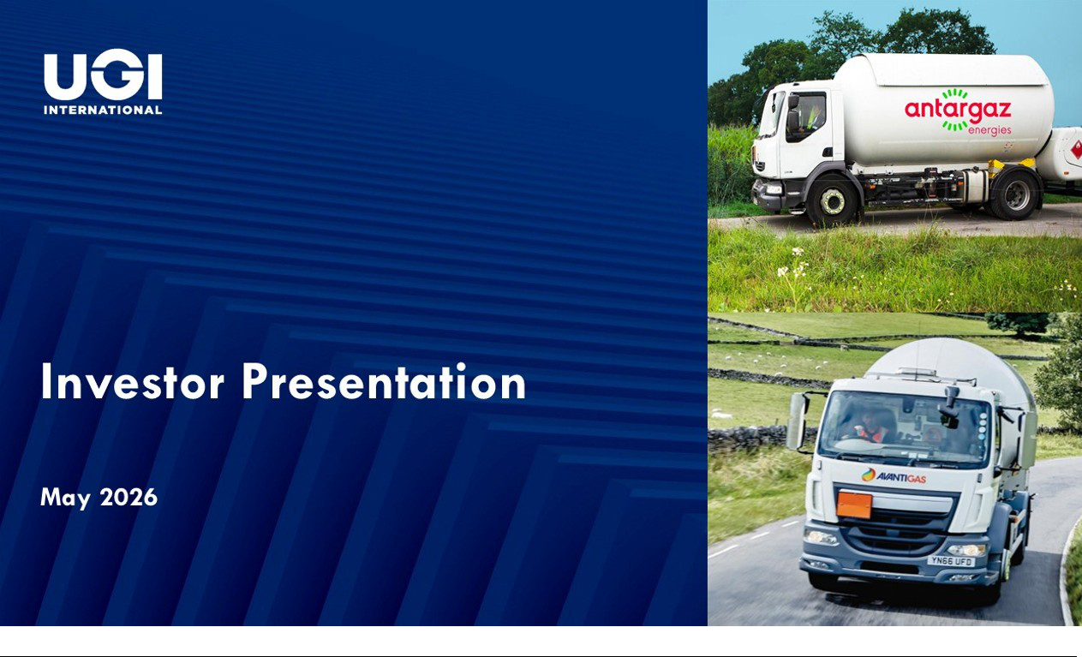

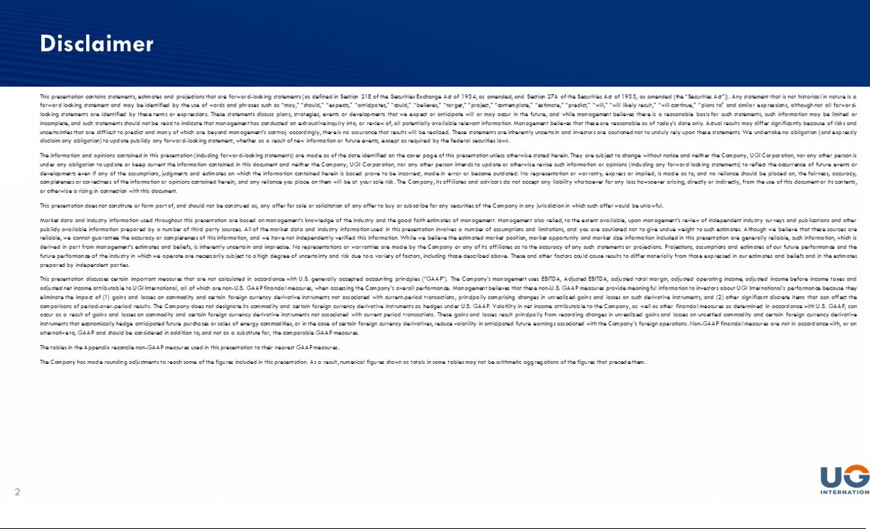



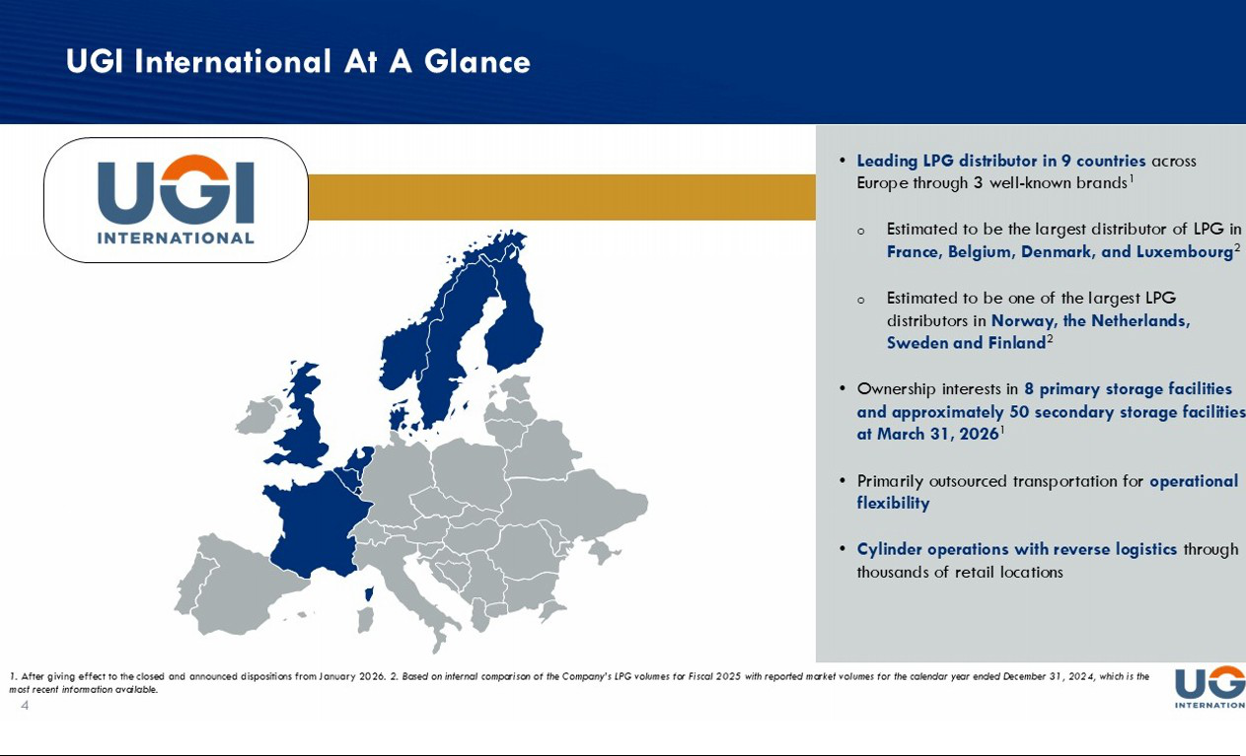

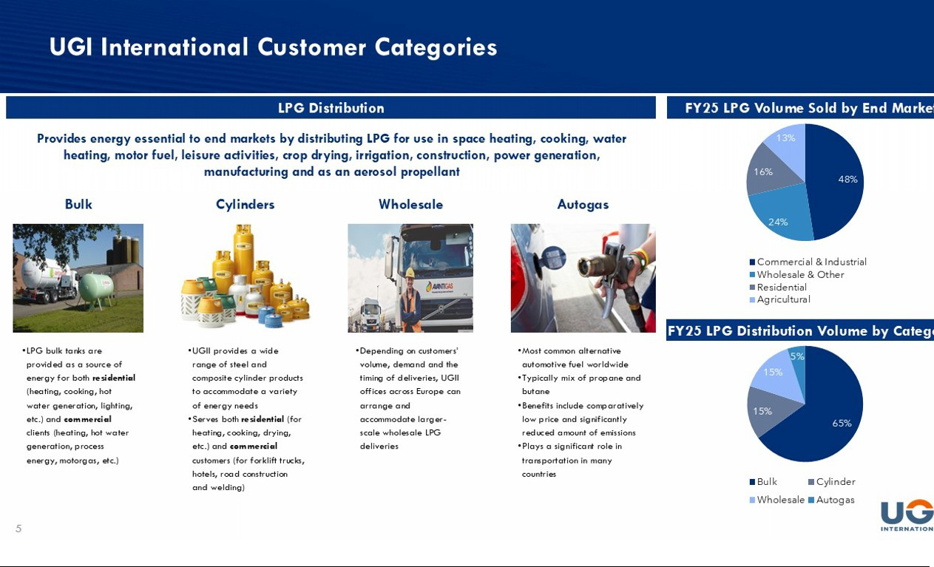

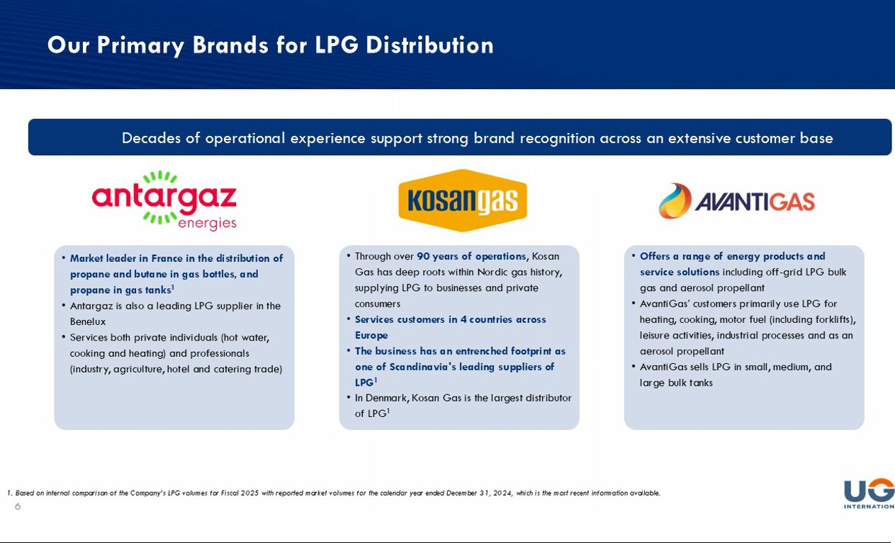

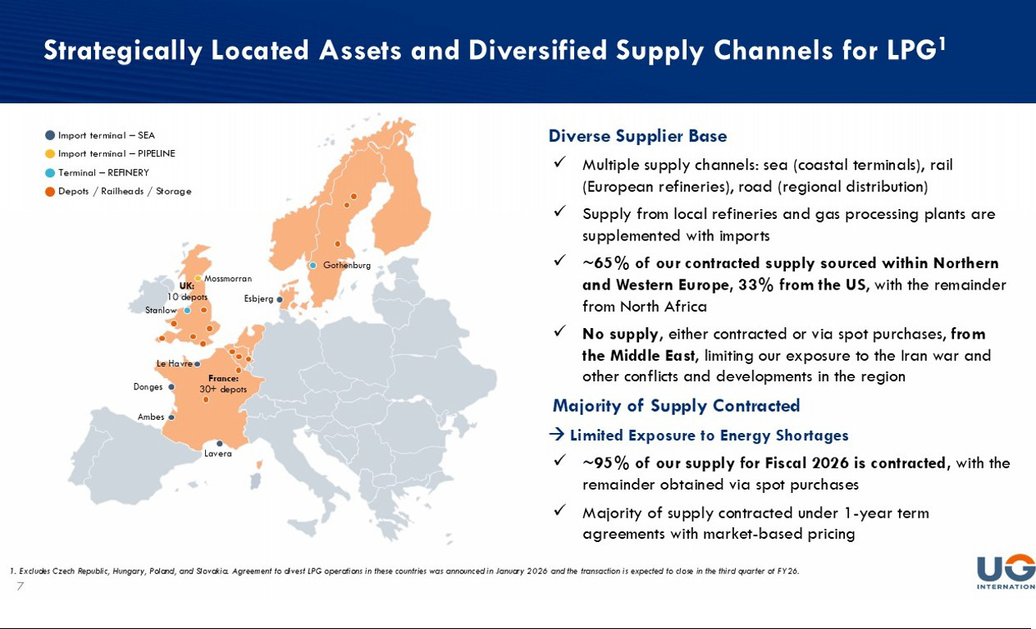

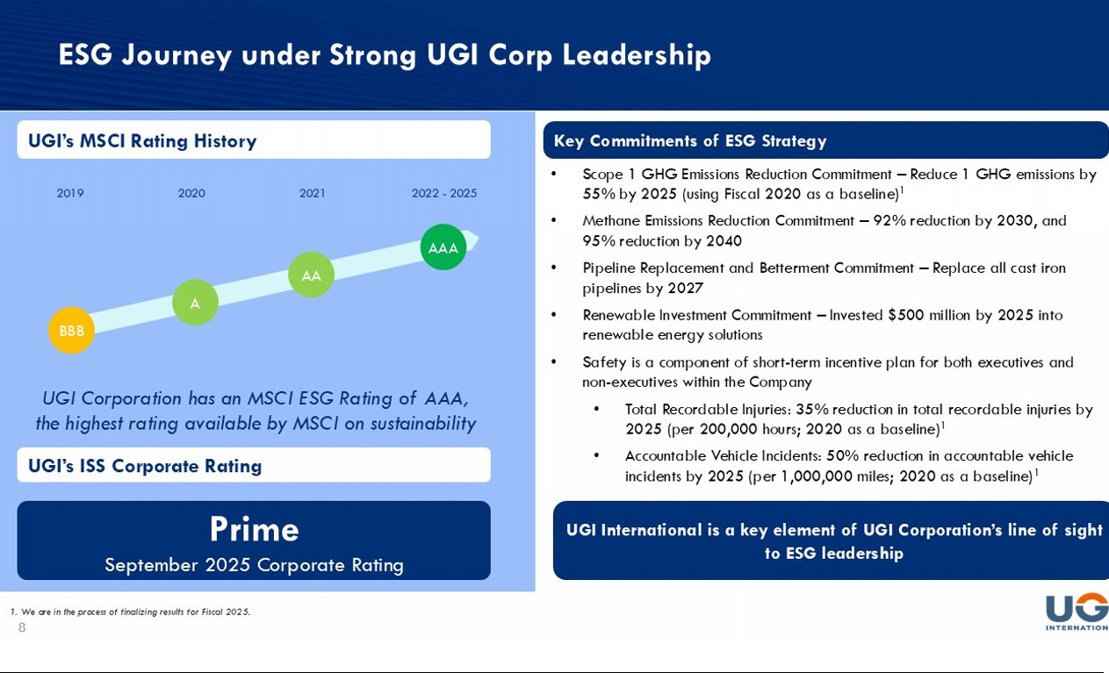



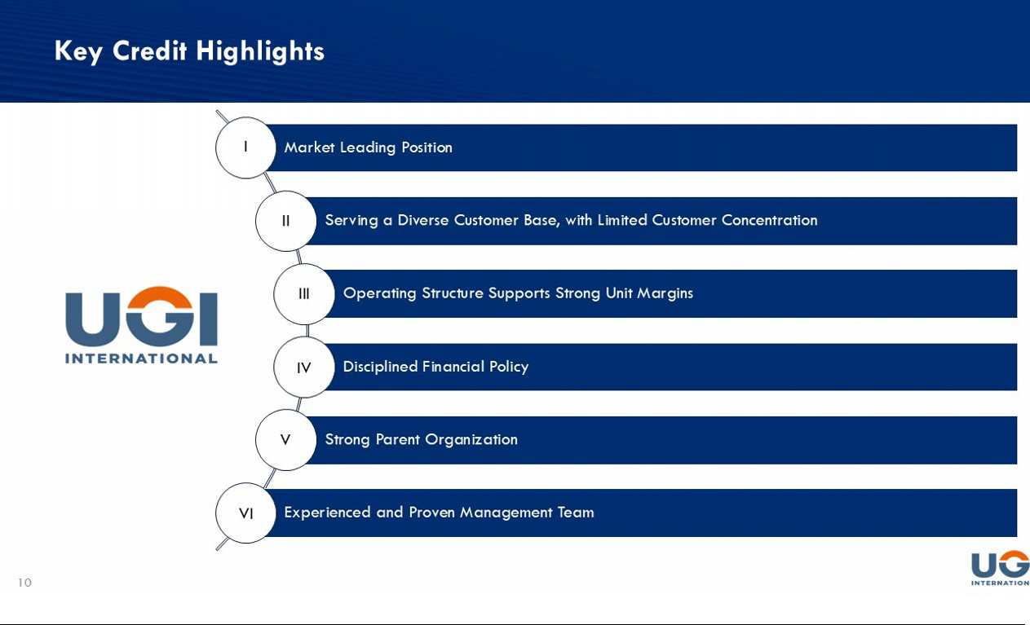

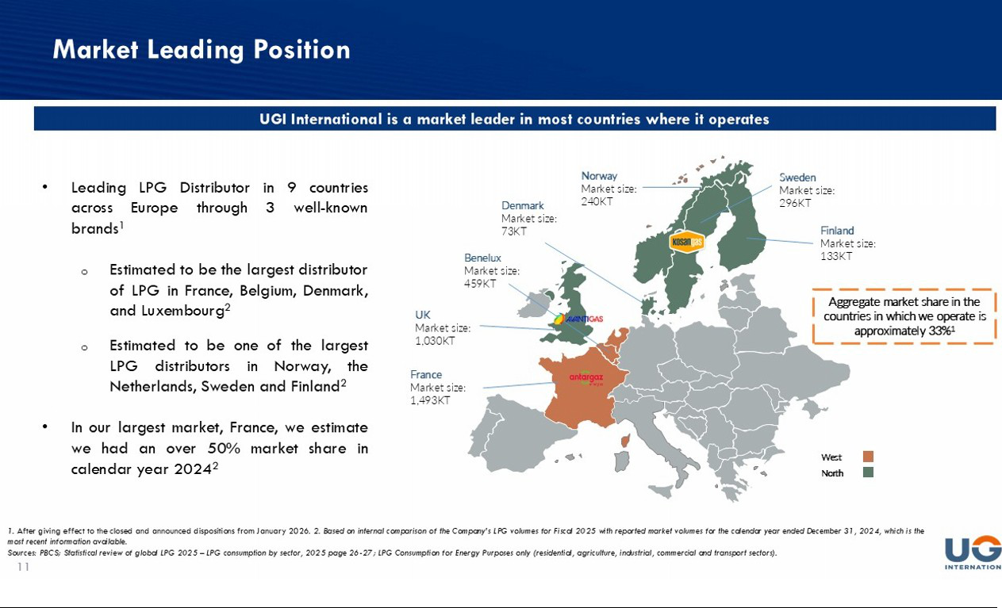

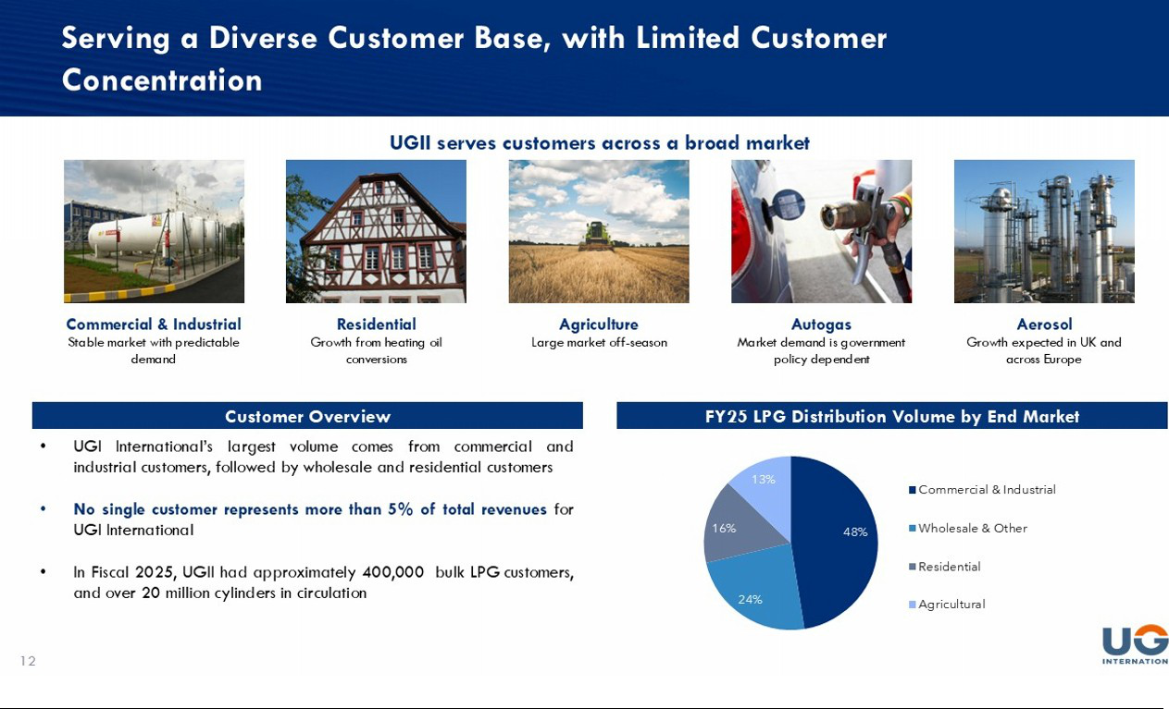

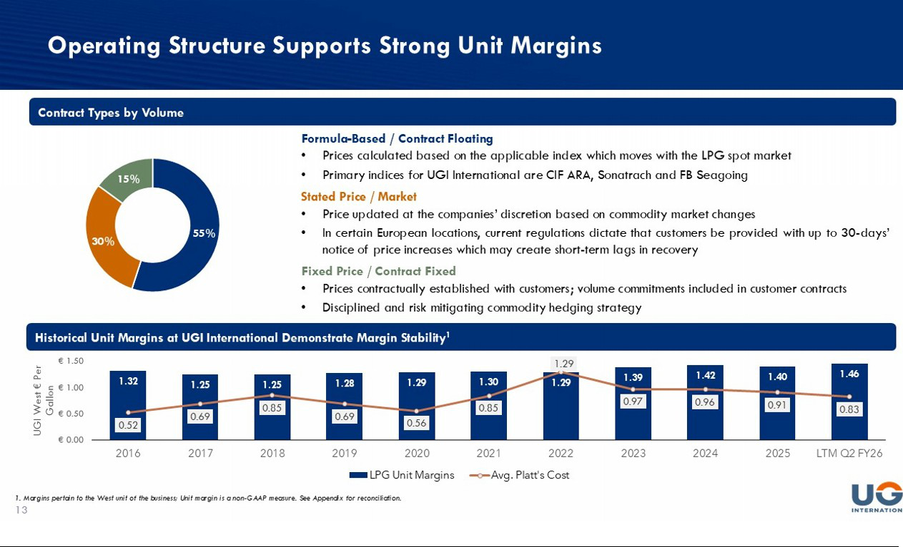

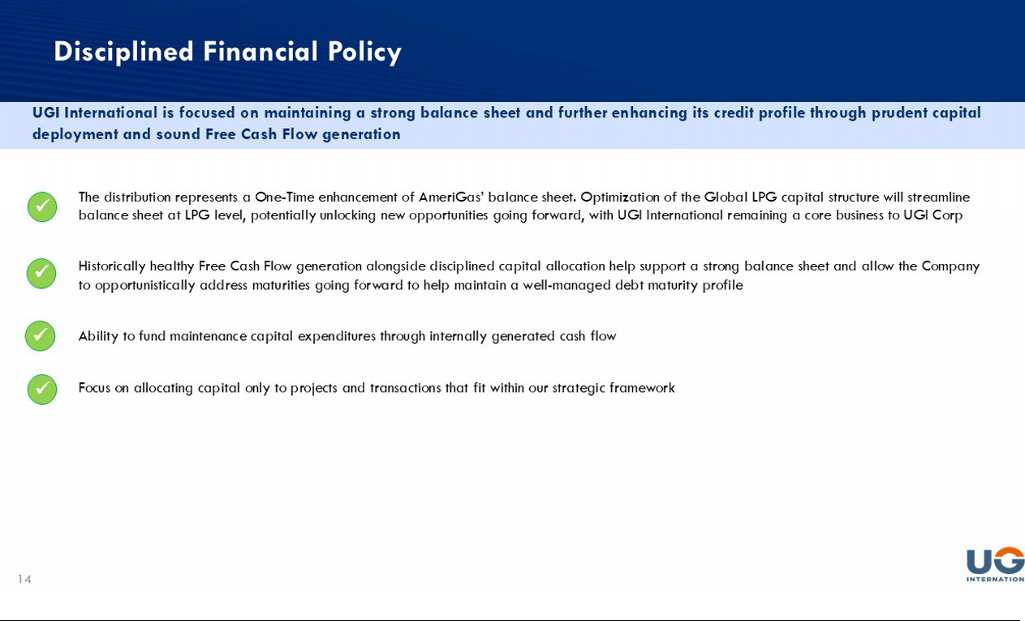

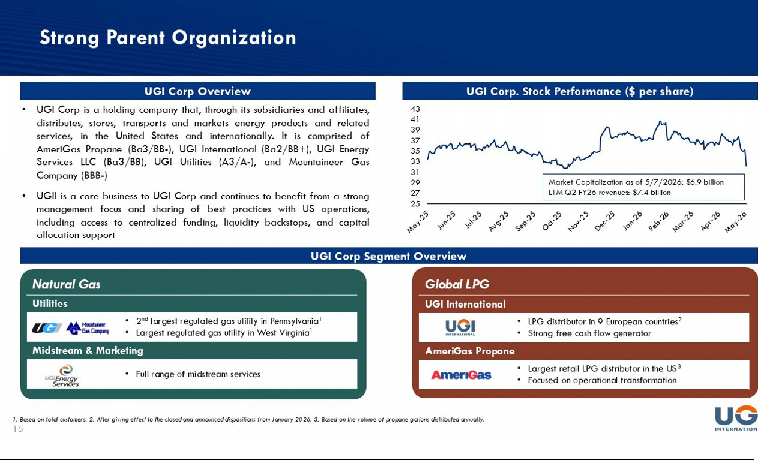

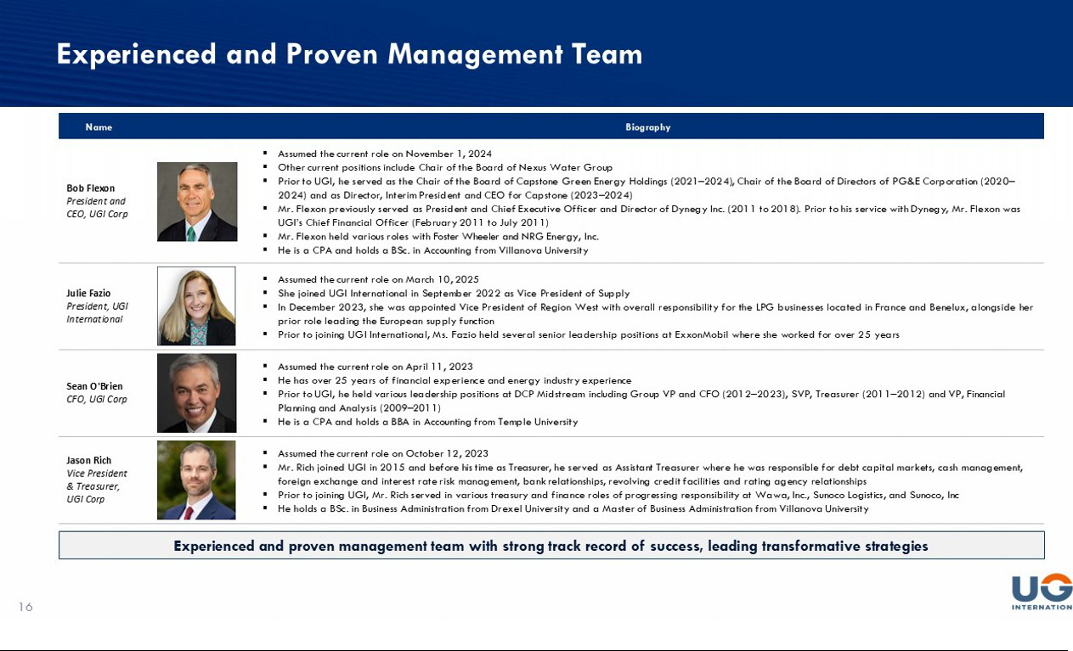



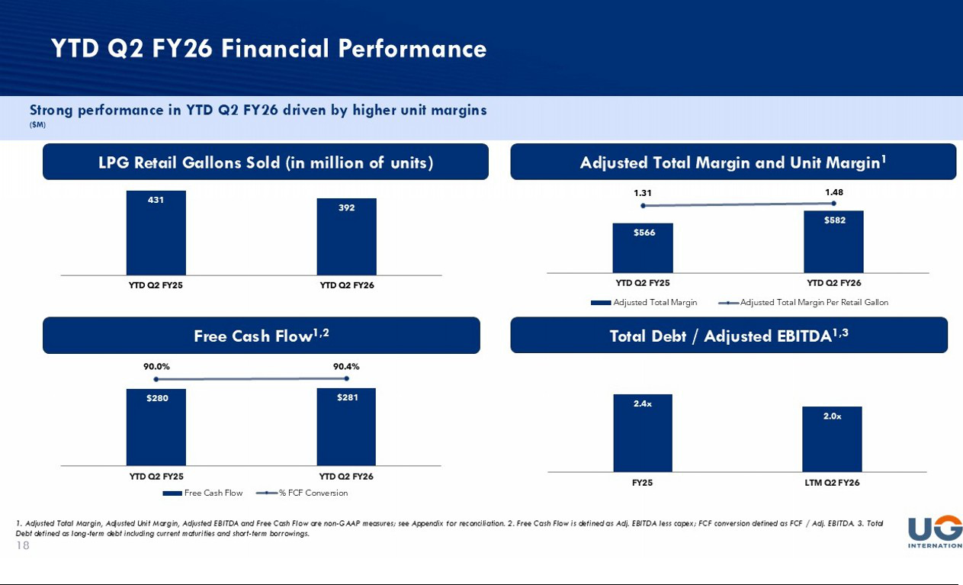

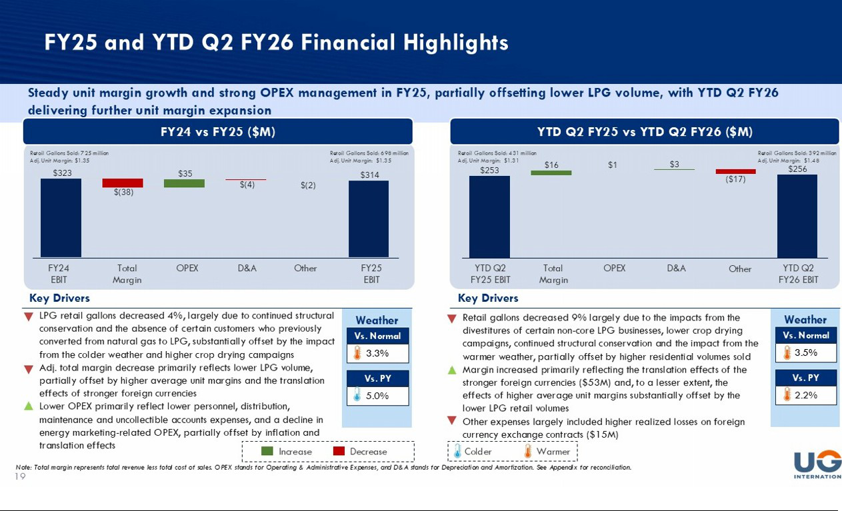

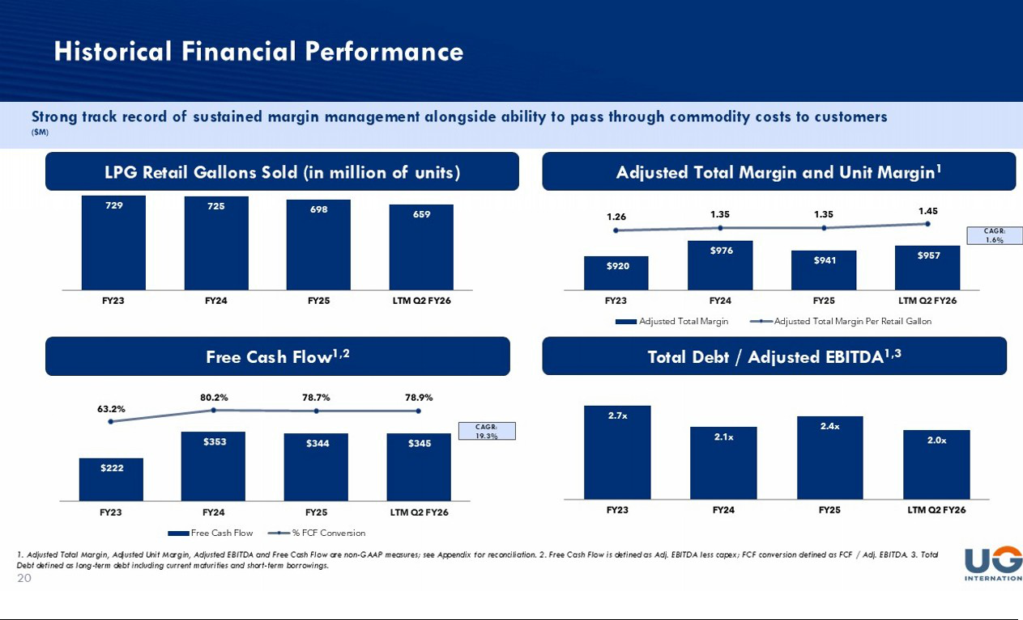

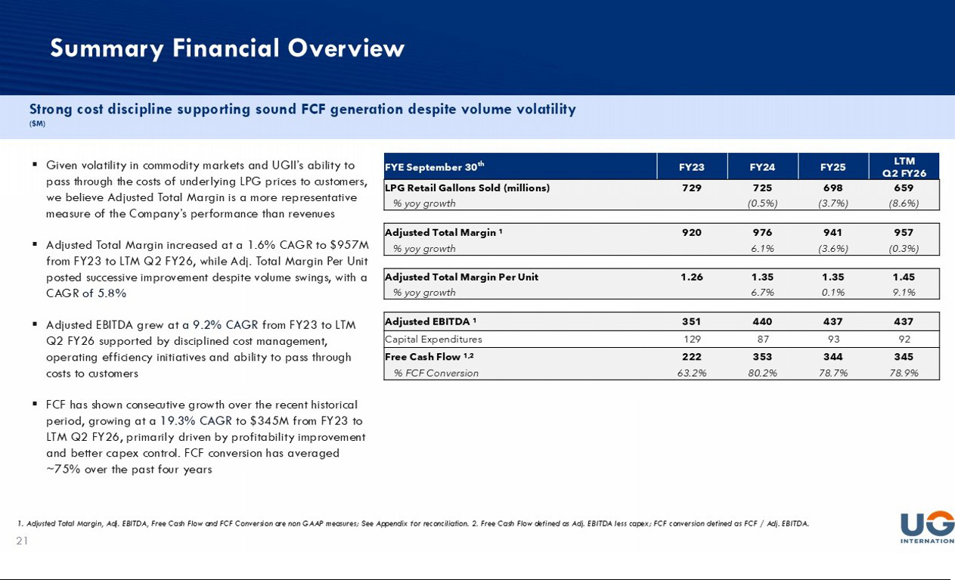

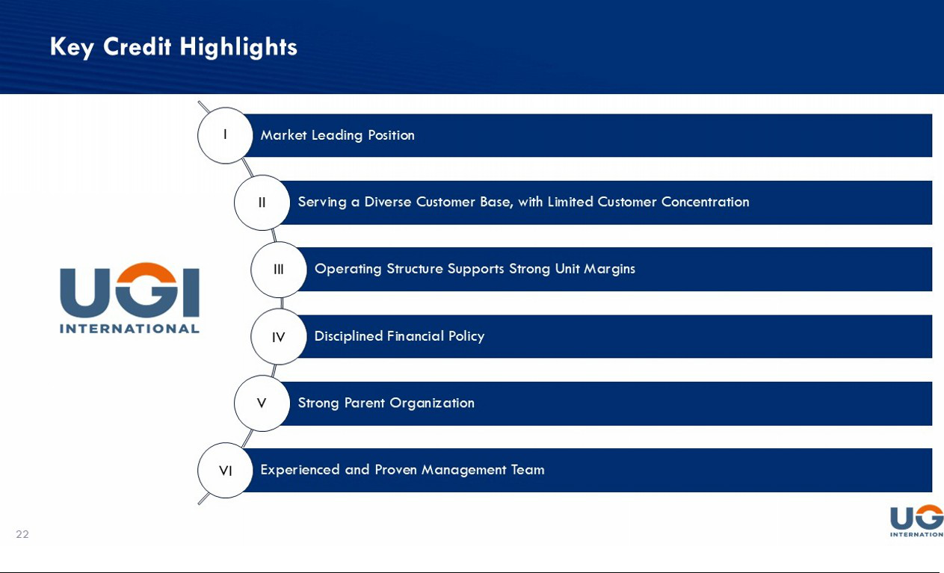



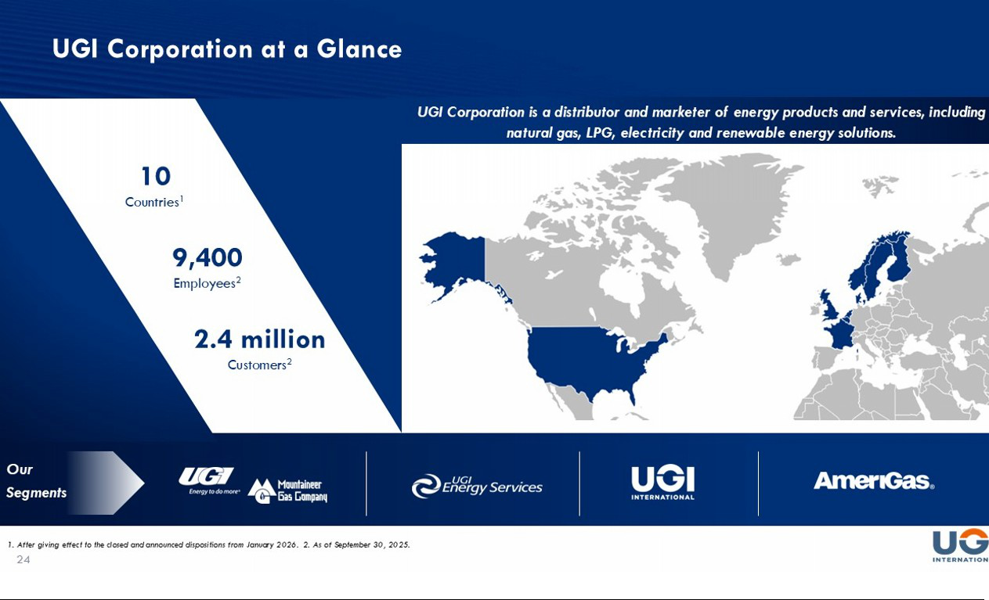

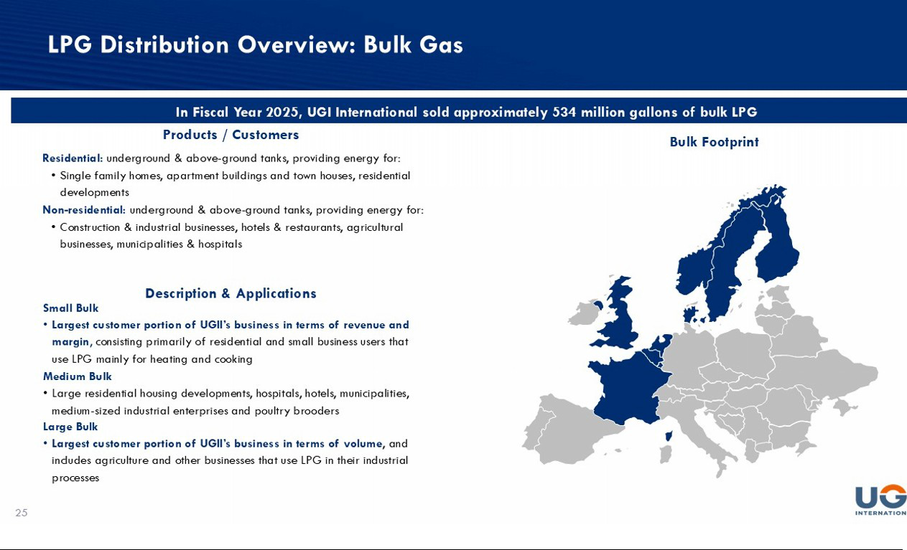

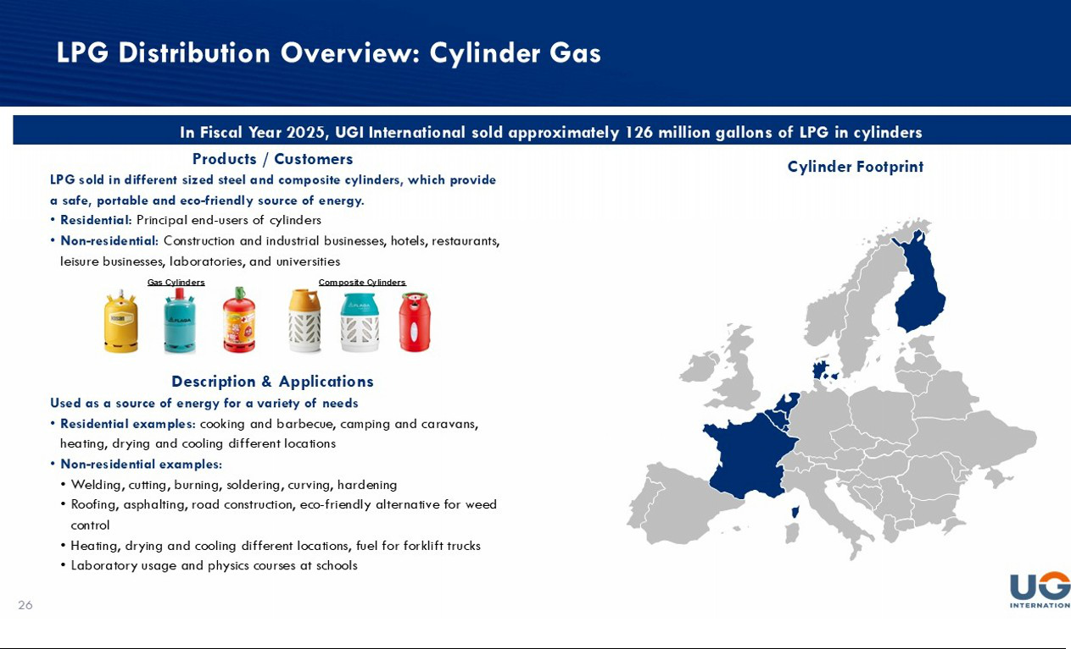

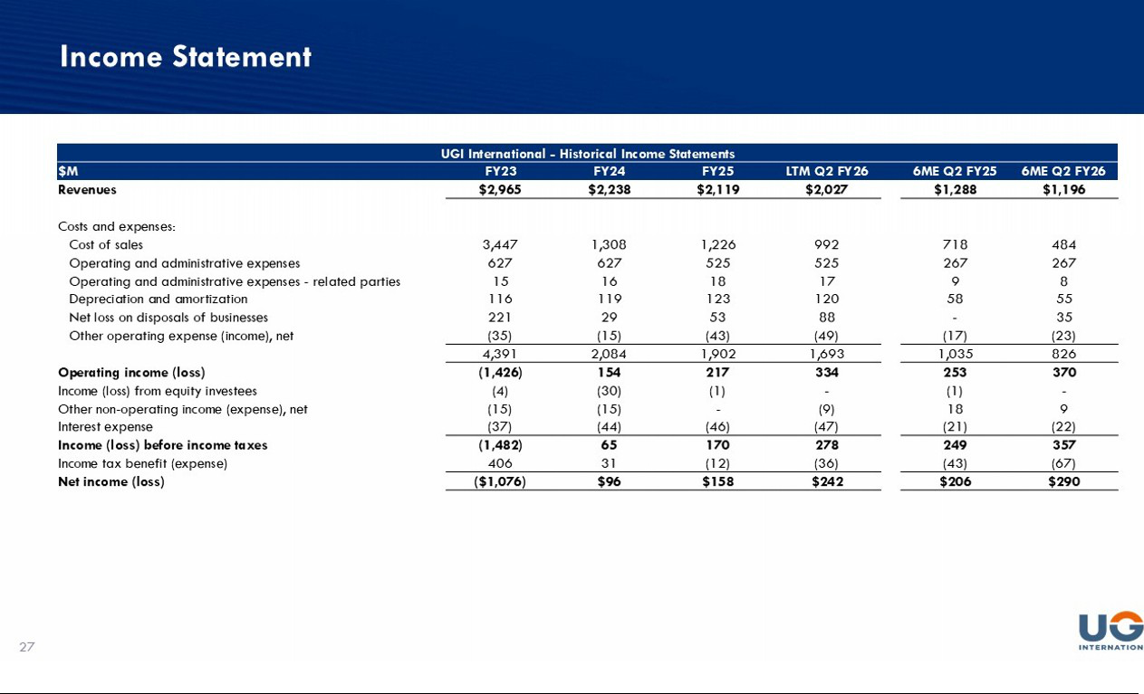

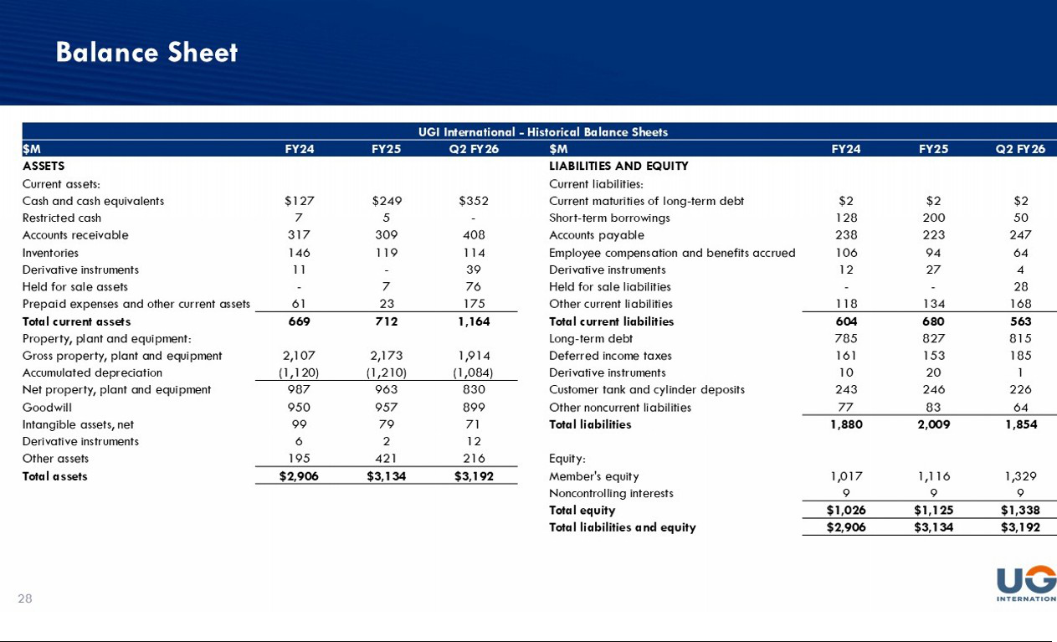

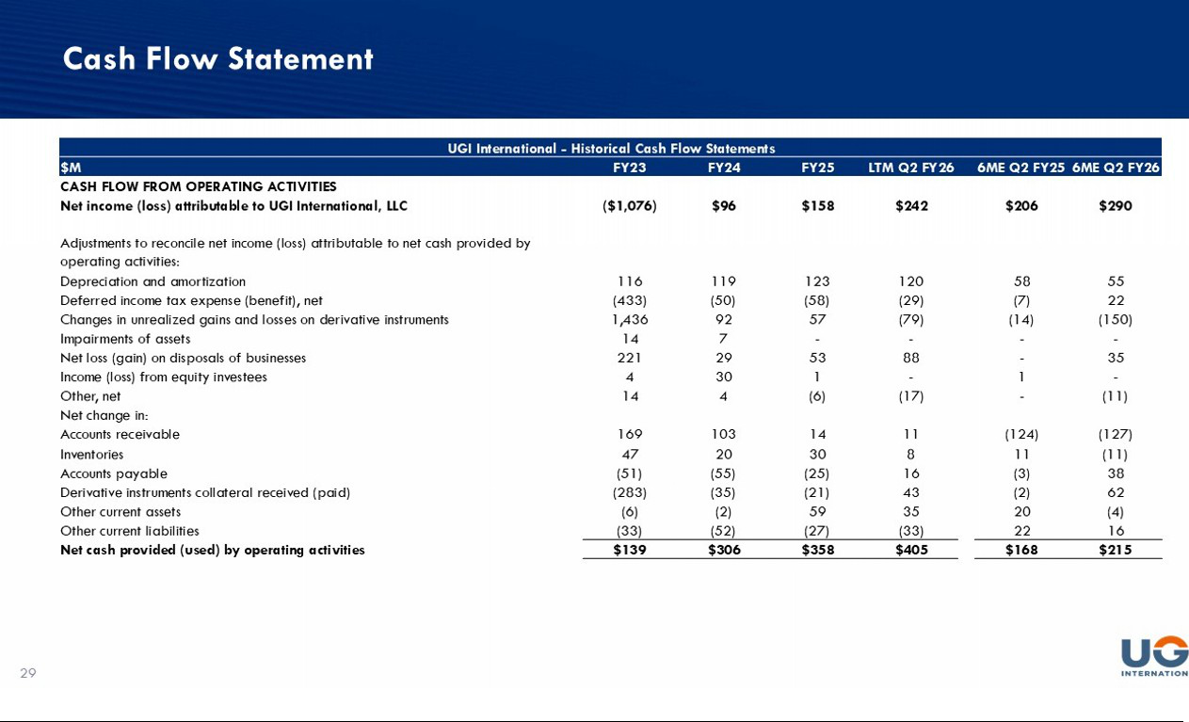

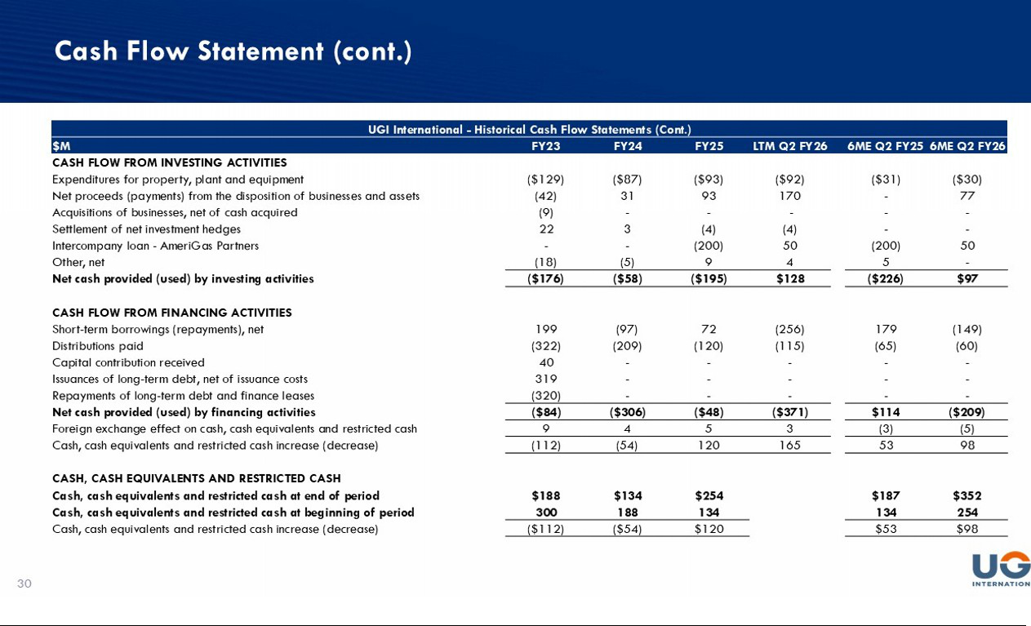

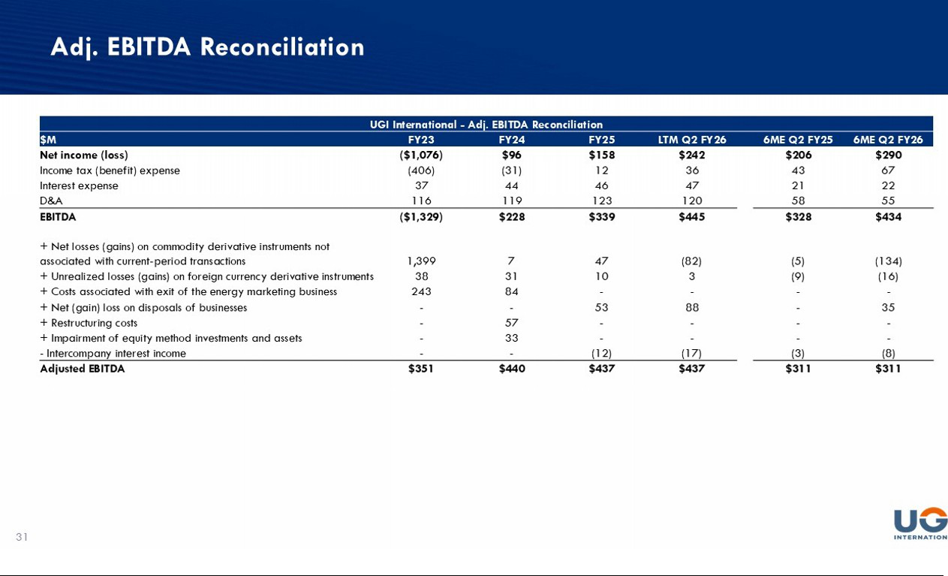

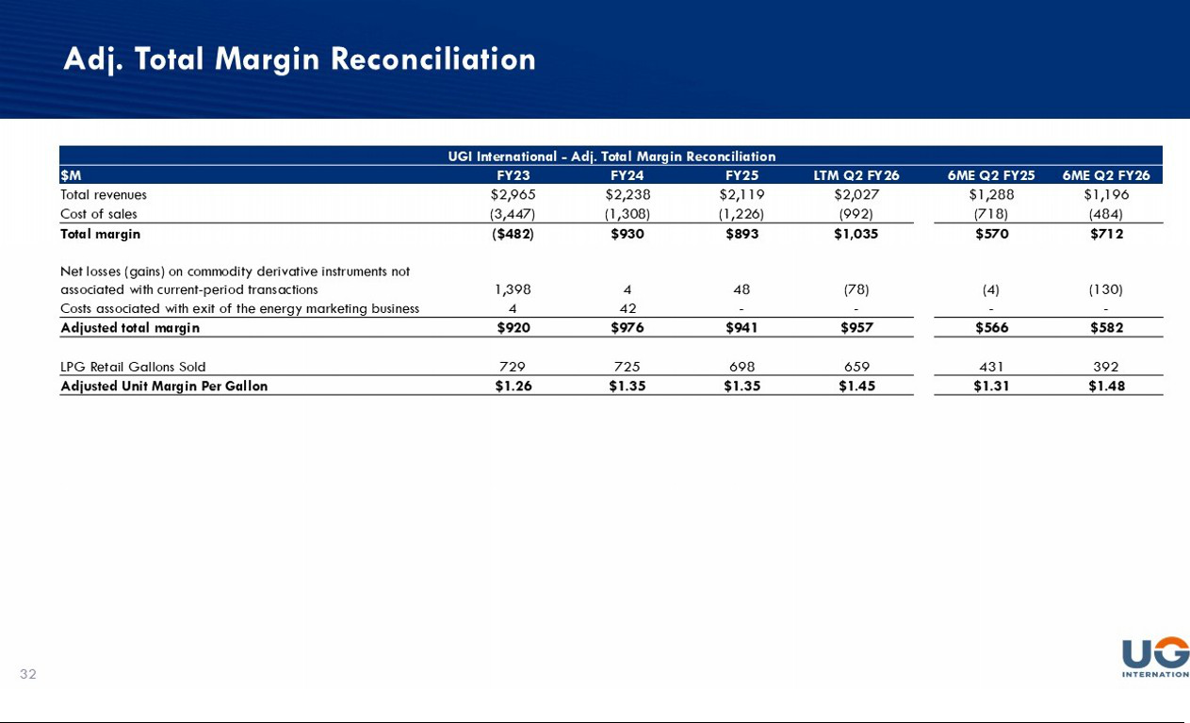

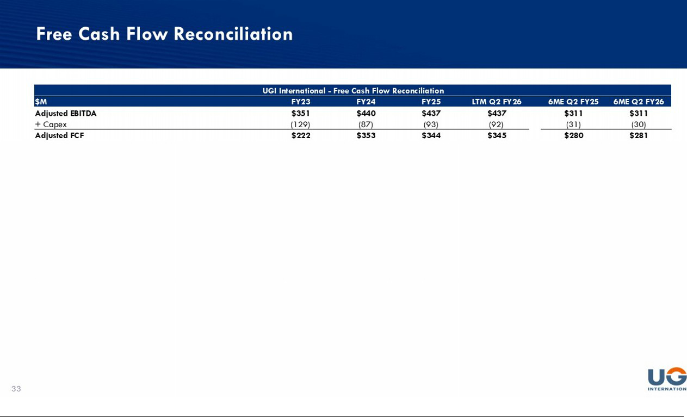

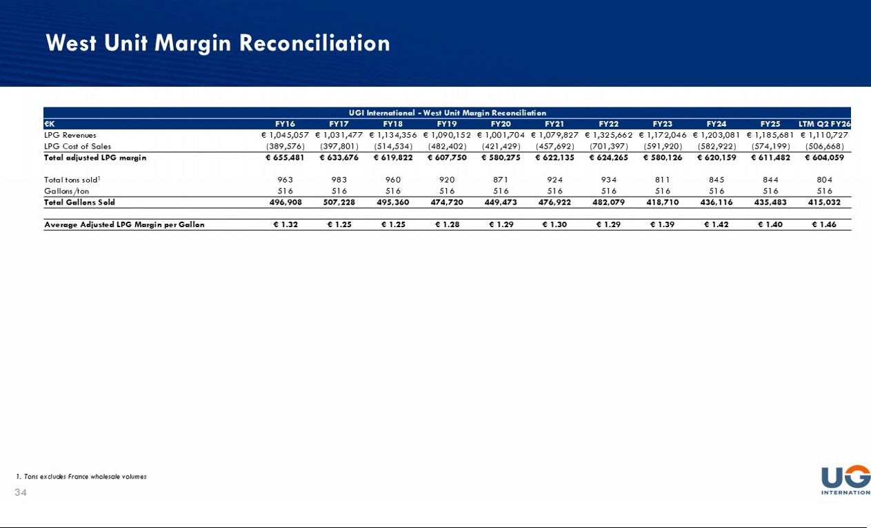

EXHIBIT 99.2
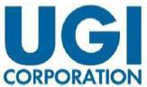

UGI International Commences Senior Notes Offering

VALLEY FORGE, PA., May 12, 2026 – UGI Corporation (“UGI” or the “Company”) (NYSE: UGI) announced today that its indirect, wholly owned subsidiary, UGI International, LLC (“UGI International”), intends to offer

€300,000,000 in aggregate principal amount of senior notes (the “Notes”) to persons reasonably believed to be qualified institutional buyers pursuant to Rule 144A under the U.S. Securities Act of 1933, as amended (the “Securities Act”), and to non-U.S. persons outside the United States in compliance with Regulation S under the Securities Act.

The Notes will be fully and unconditionally guaranteed by certain subsidiaries of UGI International that guarantee UGI International’s obligations under its existing €300,000,000 senior unsecured term loan facility (the “Term Loan”) and its existing €500,000,000 senior unsecured revolving credit facility (the “Revolving Credit Facility”), but will not be guaranteed by the Company.

UGI International intends to use the net proceeds of the issuance of the Notes to (i) repay short-term borrowings under the Revolving Credit Facility associated with the payment of a dividend to the Company, which was contributed to AmeriGas Partners, L.P., an indirect, wholly owned subsidiary of the Company (“AmeriGas”), and a portion of which the Company expects will be used by AmeriGas to repay an intercompany loan owed to UGI International, (ii) repay other amounts currently outstanding under the Revolving Credit Facility, (iii) partially prepay the Term Loan and (iv) pay fees and expenses related to the foregoing, and the remainder will be used for general corporate purposes.

The Notes offering is not conditioned upon the repayment of the intercompany loan by AmeriGas, and if UGI International does not receive some or all of the expected repayment amounts on the intercompany loan, UGI International would expect to decrease intended repayments of amounts under the Revolving Credit Facility and/or Term Loan accordingly. The Notes offering is subject to market conditions, and there can be no assurance that the issuance and sale of the Notes or the use of proceeds thereof will be consummated.

The Notes and the related guarantees will not be registered under the Securities Act or any state securities laws, and may not be offered or sold in the United States absent registration, except pursuant to an exemption from the registration requirements of the Securities Act and applicable state securities laws.

This announcement is neither an offer to sell nor a solicitation of an offer to buy the Notes, the guarantees or any other securities, and shall not constitute an offer, solicitation or sale in any jurisdiction in which such an offer, solicitation or sale would be unlawful.

Cautionary Statement Concerning Forward-Looking Statements

This press release contains statements, estimates, and projections that are forward-looking statements (as defined in Section 21E of the U.S. Securities Exchange Act of 1934, as amended, and Section 27A of the Securities Act), including statements regarding the aggregate principal amount of the Notes to be sold or the intended use of proceeds from the offering of the Notes. Such statements use forward-looking words such as “believe,” “plan,” “anticipate,” “continue,” “estimate,” “expect,” “may,” “intend” or other similar words and terms of similar meaning, although not all forward-looking statements contain such words. These statements discuss plans, strategies, events or developments that we expect or anticipate will or may occur in the future. Management believes that these are reasonable as of today’s date only. Actual results may differ significantly because of risks and uncertainties that are difficult to predict and many of which are beyond management’s control; accordingly, there is no assurance that results will be realized. You should read the Company’s most recent Annual Report on Form 10-K and Quarterly Reports on Form 10-Q for a more extensive list of factors that could affect results. The Company undertakes no obligation (and expressly disclaims any obligation) to update publicly any forward-looking statement, whether as a result of new information or future events, except as required by the federal securities laws.

About UGI

UGI Corporation (NYSE: UGI) is a distributor and marketer of energy products and services in the U.S. and Europe. UGI offers safe, reliable, affordable and sustainable energy solutions to customers through its subsidiaries, which provide natural gas transmission and distribution, electric generation and distribution, midstream services, propane distribution, renewable natural gas generation, distribution and marketing and energy marketing services.

INVESTOR RELATIONS

610-337-1000

Tameka Morris, ext. 6297

Arnab Mukherjee, ext. 7498

