UNITED STATES

SECURITIES AND EXCHANGE COMMISSION

WASHINGTON, D.C. 20549

FORM 8-K

CURRENT REPORT

Pursuant to Section 13 or 15(d)

of The Securities Exchange Act of 1934

Date of Report (Date of earliest event reported): May 11, 2026

UGI Corporation

(Exact Name of Registrant as Specified in Its Charter)

Pennsylvania

1-11071

23-2668356

(State or Other Jurisdiction

of Incorporation)

(Commission

File Number)

(IRS Employer
Identification No.)

500 North Gulph Road, King of Prussia, PA 19406

(Address of Principal Executive Offices) (Zip Code)

Registrant’s Telephone Number, Including Area Code: 610 337-1000

Not Applicable

Former Name or Former Address, if Changed Since Last Report

Check the appropriate box below if the Form 8-K filing is intended to simultaneously satisfy the filing obligation of the registrant under any of the following provisions:

- Written communications pursuant to Rule 425 under the Securities Act (17 CFR 230.425)

- Soliciting material pursuant to Rule 14a-12 under the Exchange Act (17 CFR 240.14a-12)

- Pre-commencement communications pursuant to Rule 14d-2(b) under the Exchange Act (17 CFR 240.14d-2(b))

- Pre-commencement communications pursuant to Rule 13e-4(c) under the Exchange Act (17 CFR 240.13e-4(c))

Securities registered pursuant to Section 12(b) of the Act:

Title of each class | Trading Symbol(s) | Name of each exchange on which registered
Common Stock, without par value | UGI | New York Stock Exchange

Indicate by check mark whether the registrant is an emerging growth company as defined in Rule 405 of the Securities Act of 1933 (§230.405 of this chapter) or Rule 12b-2 of the Securities Exchange Act of 1934 (§240.12b-2 of this chapter).

Emerging growth company ☐

If an emerging growth company, indicate by check mark if the registrant has elected not to use the extended transition period for complying with any new or revised financial accounting standards provided pursuant to Section 13(a) of the Exchange Act. ☐

Item 7.01 Regulation FD Disclosure.

On May 11, 2026, AmeriGas Partners, L.P. (“AmeriGas Partners”) and AmeriGas Finance Corp. (“Finance Corp.” and, together with AmeriGas Partners, the “Issuers”), indirect, wholly owned subsidiaries of UGI Corporation (the “Company”), commenced a private offering (the “Offering”) pursuant to exemptions from the registration requirements of the Securities Act of 1933, as amended (the “Securities Act”), for the issuance of $500.0 million in aggregate principal amount of senior notes due 2031 (the “Notes”). The Offering is subject to market conditions.

In addition, on May 11, 2026 the Issuers announced the commencement of offers to purchase for cash (i) any and all of the Issuers’ outstanding 5.750% Senior Notes due 2027 (the “2027 Notes”) upon the terms and subject to the conditions set forth in the Offer to Purchase, dated May 11, 2026, and the related Letter of Transmittal and Notice of Guaranteed Delivery (the “2027 Notes Tender Offer”) and (ii) up to $175.0 million aggregate principal amount (the “Tender Cap”) of the Issuers’ outstanding 9.375% Senior Notes due 2028 (the “2028 Notes”) upon the terms and subject to the conditions set forth in the Offer to Purchase, dated May 11, 2026 (the “2028 Notes Tender Offer” and, together with the 2027 Notes Tender Offer, the “Tender Offers”).

The Issuers will not be required to purchase any of the corresponding Notes tendered unless certain conditions have been satisfied, including, but not limited to, the Issuers’ successful completion of one or more financing transactions, in an amount sufficient, together with cash previously received by AmeriGas Partners in connection with an equity contribution by its parent, originally funded by UGI International, LLC (“UGI International”), a wholly owned indirect subsidiary of the Company (the “Equity Contribution”), and cash on hand, to (i) fund the purchase of validly tendered 2027 Notes accepted for purchase in the 2027 Notes Tender Offer, and the redemption of any such 2027 Notes remaining thereafter, (ii) fund the purchase up to the Tender Cap of 2028 Notes accepted for purchase in the 2028 Notes Tender Offer, (iii) repay $150.0 million in outstanding indebtedness under the intercompany loan between AmeriGas Partners and UGI International and (iv) pay all related fees and expenses associated with the foregoing.

Substantially concurrently with the commencement of the 2027 Notes Tender Offer, the Issuers will issue a conditional notice of full redemption to redeem any 2027 Notes not purchased in the 2027 Notes Tender Offer and that remain outstanding pursuant to the indenture governing the 2027 Notes (the “2027 Notes Indenture”). The redemption of the 2027 Notes will be conditioned upon the receipt by the Issuers of funds in an amount sufficient to (i) fund the purchase of validly tendered 2027 Notes accepted for purchase in the 2027 Notes Tender Offer, and the redemption of any such 2027 Notes remaining thereafter, (ii) fund the purchase up to the Tender Cap of 2028 Notes accepted for purchase in the 2028 Notes Tender Offer, (iii) repay $150.0 million in outstanding indebtedness under the intercompany loan between AmeriGas Partners and UGI International and (iv) pay all related fees and expenses associated with the foregoing. Promptly following the expiration date of the 2027 Notes Tender Offer, as set forth in the Offer to Purchase relating to the 2027 Notes Tender Offer, the Issuers currently intend to satisfy and discharge their obligations under the 2027 Notes and the 2027 Notes Indenture by depositing with the paying agent for the 2027 Notes sufficient funds to pay the principal of, premium on and accrued and unpaid interest on the 2027 Notes to, but excluding, the redemption date. The redemption of the 2027 Notes is being made solely pursuant to the conditional notice of redemption that has been delivered pursuant to the 2027 Notes Indenture, and nothing contained herein constitutes a notice of redemption thereof.

The Issuers intend to use the net proceeds of the issuance of the Notes, together with the Equity Contribution and cash on hand, to (i) fund the Tender Offers and the redemption of any 2027 Notes not repurchased in the 2027 Notes Tender Offer, (ii) repay $150.0 million in outstanding indebtedness under an intercompany loan between AmeriGas Partners and UGI International and (iii) pay related fees and expenses.

The Issuers have made available a presentation to prospective investors in connection with marketing the Offering. The investor presentation disclosed certain information that supplements or updates certain prior disclosures of the Company. Pursuant to Regulation FD, the Company is furnishing herewith such information as Exhibit 99.1 to this Current Report on Form 8‑K.

This information, including Exhibit 99.1 referenced herein, is “furnished” and shall not be deemed “filed” for purposes of Section 18 of the Securities Exchange Act of 1934, as amended (the “Exchange Act”), or otherwise subject to the liabilities of that section. It may be incorporated by reference in a registration statement or filing by the Company under the Exchange Act, only if and to the extent such subsequent filing specifically references the information herein as being incorporated by reference in such filing.

This Current Report on Form 8‑K shall not constitute an offer to sell or the solicitation of an offer to buy the offered securities, nor shall there be any sales of securities in any jurisdiction in which such offer, solicitation or sale would be unlawful prior to registration or qualification under the securities laws of any such jurisdiction.

Item 8.01 Other Events.

On May 11, 2026, the Company issued a press release announcing the Offering. A copy of the Press Release announcing the Offering is attached hereto as Exhibit 99.2.

On May 11, 2026, the Company issued a press release announcing the commencement of the Tender Offers. A copy of the Press Release announcing the Tender Offers is attached hereto as Exhibit 99.3.

Item 9.01 Financial Statements and Exhibits.

(d) Exhibits.

Exhibit

Number:

99.1

99.2

99.3

104

Description

The Investor Presentation of AmeriGas Partners, L.P. dated May 2026.

Press Release of UGI Corporation dated May 11, 2026 announcing the private offering of $500.0 million of senior notes due 2031 by AmeriGas Partners, L.P. and AmeriGas Finance Corp.

Press Release of UGI Corporation dated May 11, 2026 announcing the commencement of cash tender offers for (i) any and all of the AmeriGas Partners, L.P.’s and AmeriGas Finance Corp.’s then-outstanding 5.750% Senior Notes due 2027 and (ii) up to $175.0 million aggregate principal amount of AmeriGas Partners, L.P.’s and AmeriGas Finance Corp.’s then-outstanding 9.375% Senior Notes due 2028.

Cover Page Interactive Data File (formatted as inline XBRL).

SIGNATURES

Pursuant to the requirements of the Securities Exchange Act of 1934, the registrant has duly caused this report to be signed on its behalf by the undersigned hereunto duly authorized.

 | UGI Corporation
May 11, 2026 | By: | /s/ Jessica A. Milner
 | Name: | Jessica A. Milner
 | Title: | Secretary

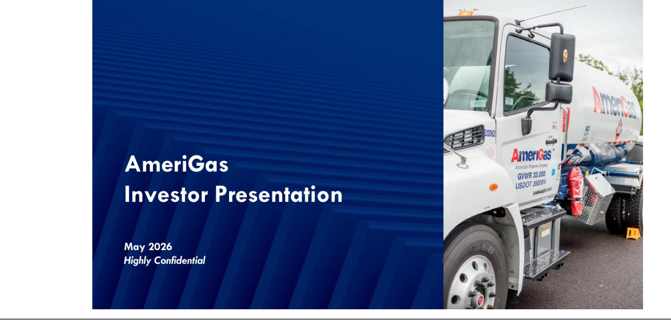

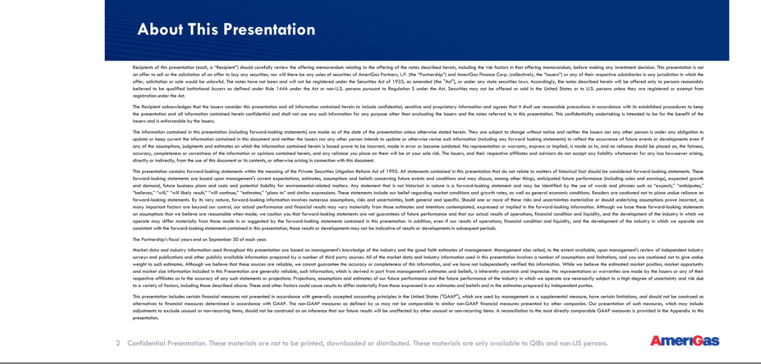

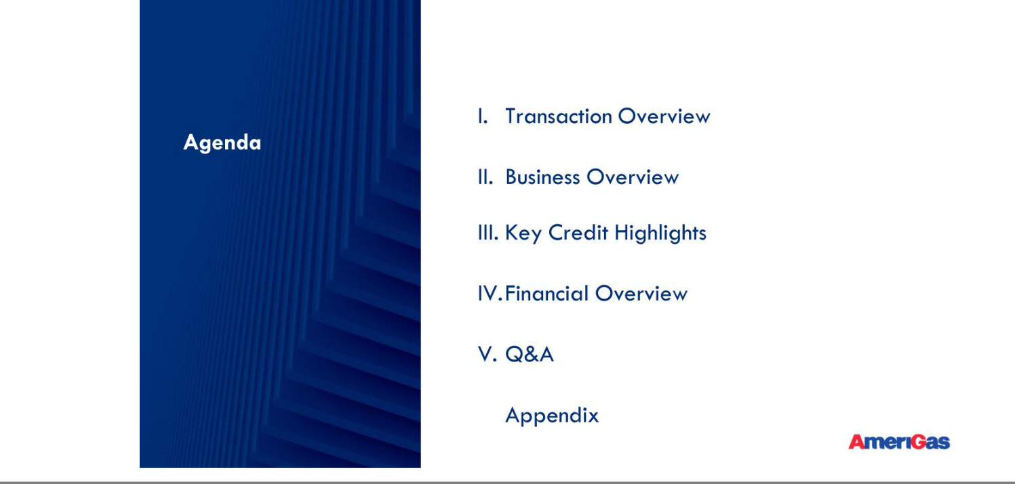

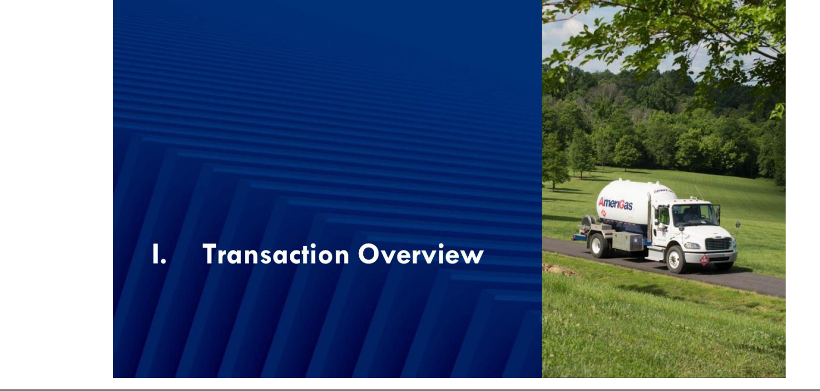

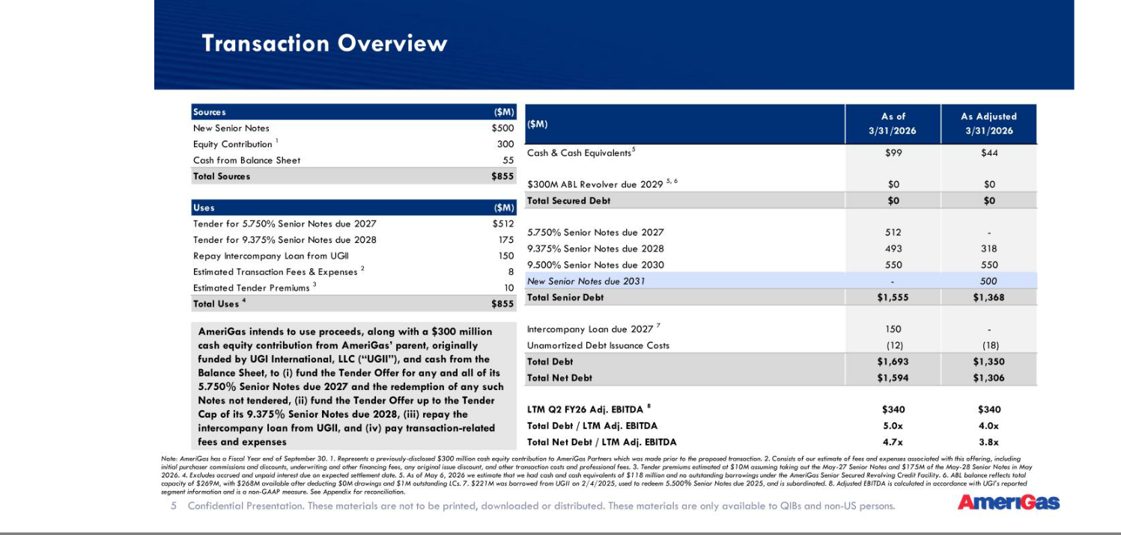

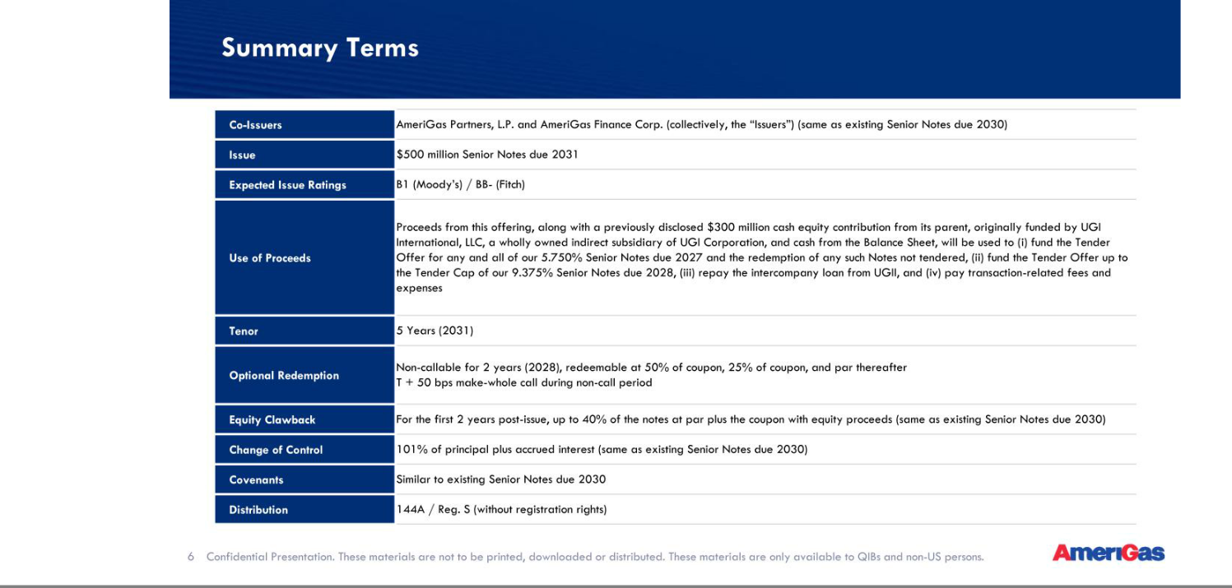

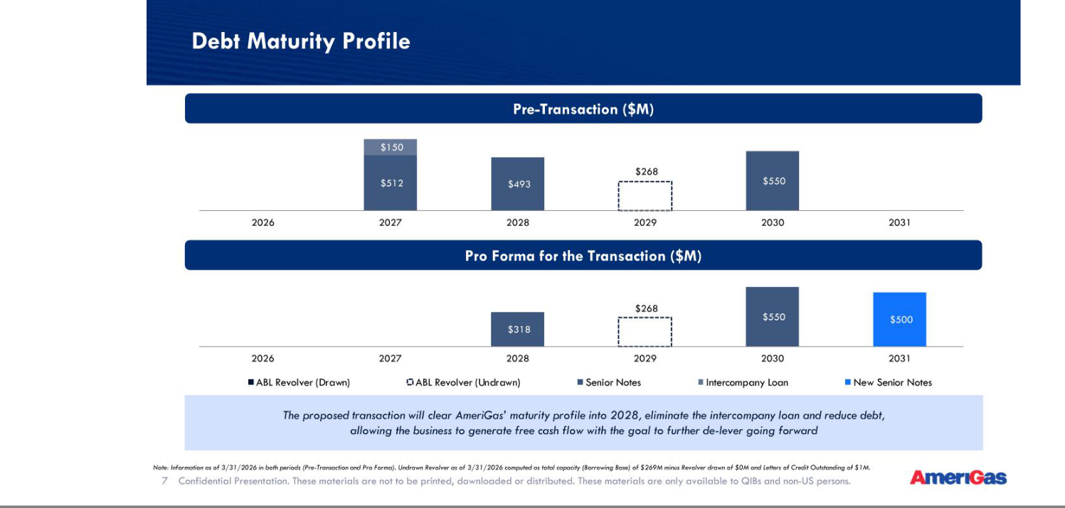

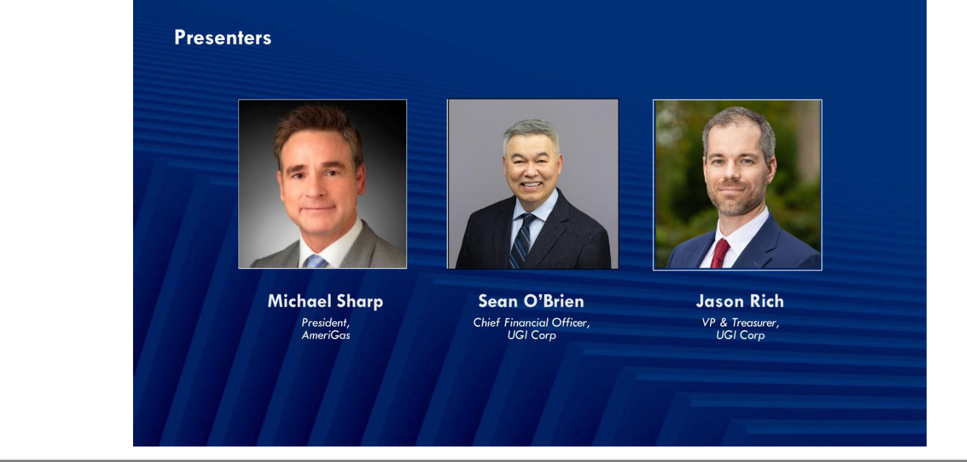

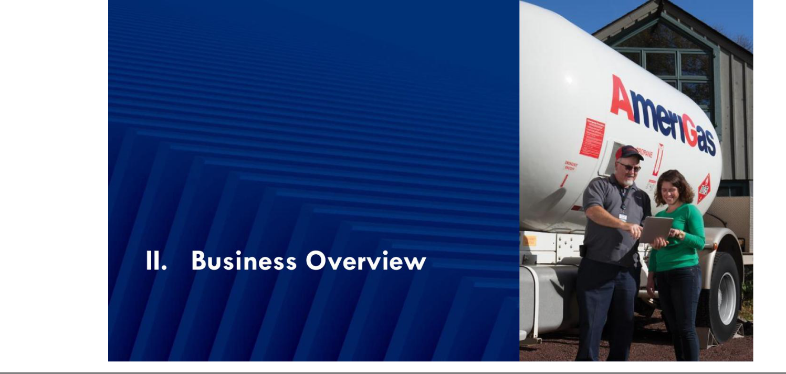

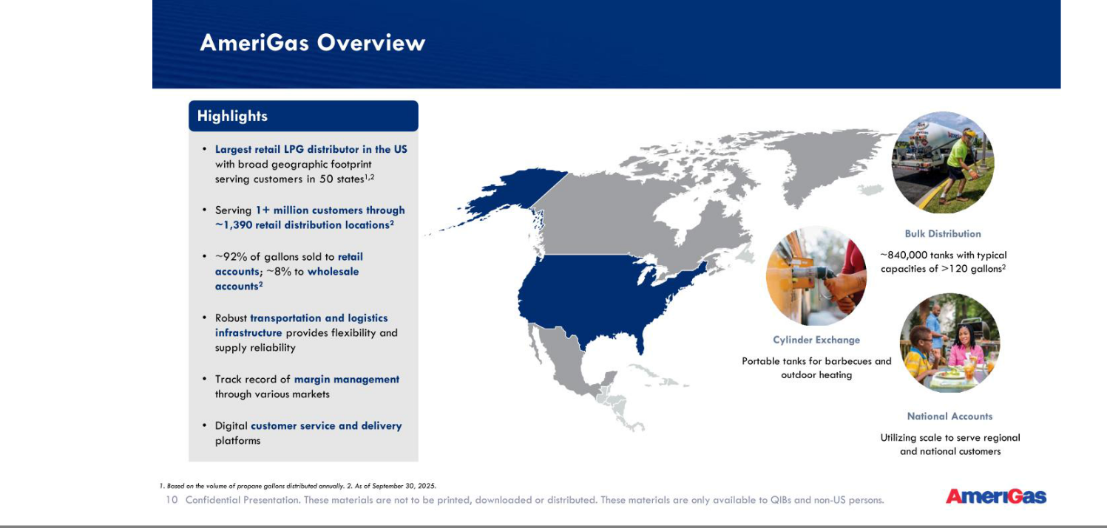

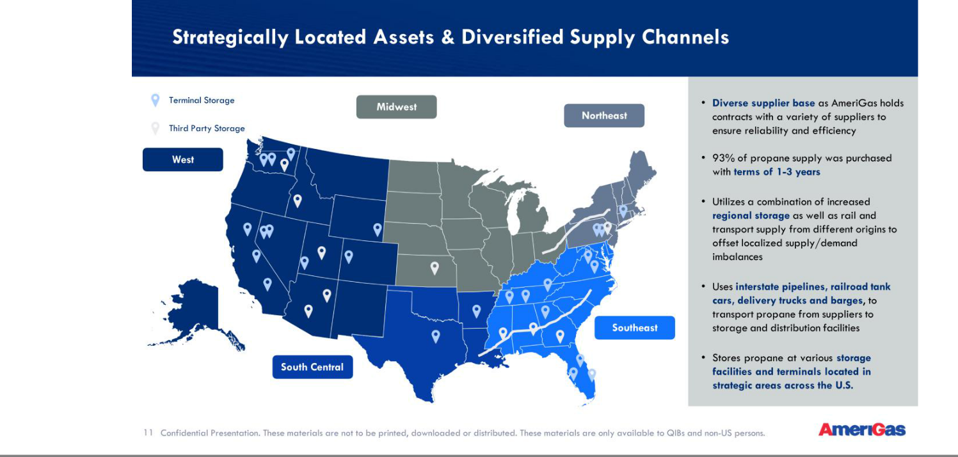

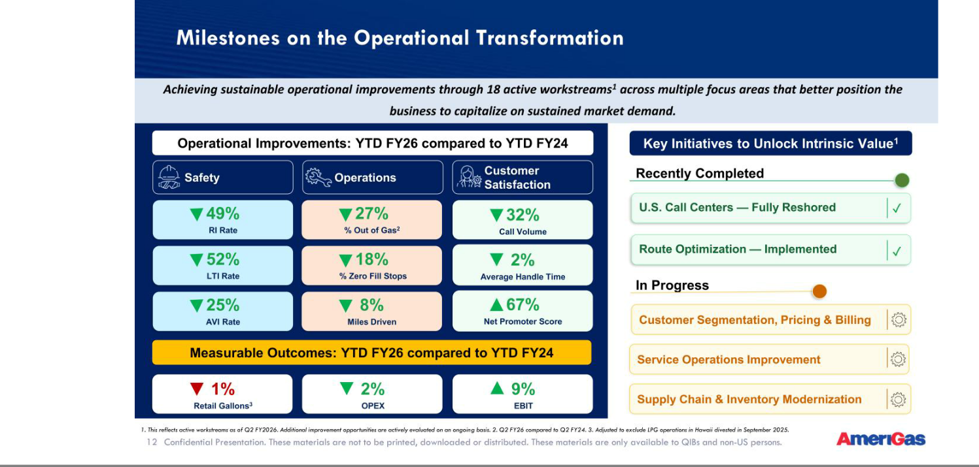



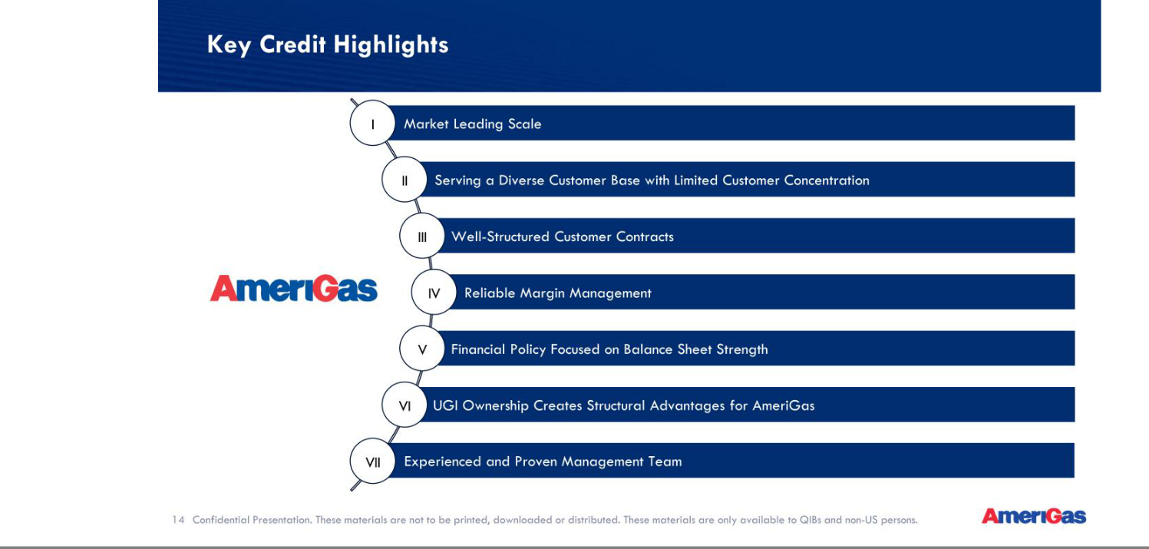

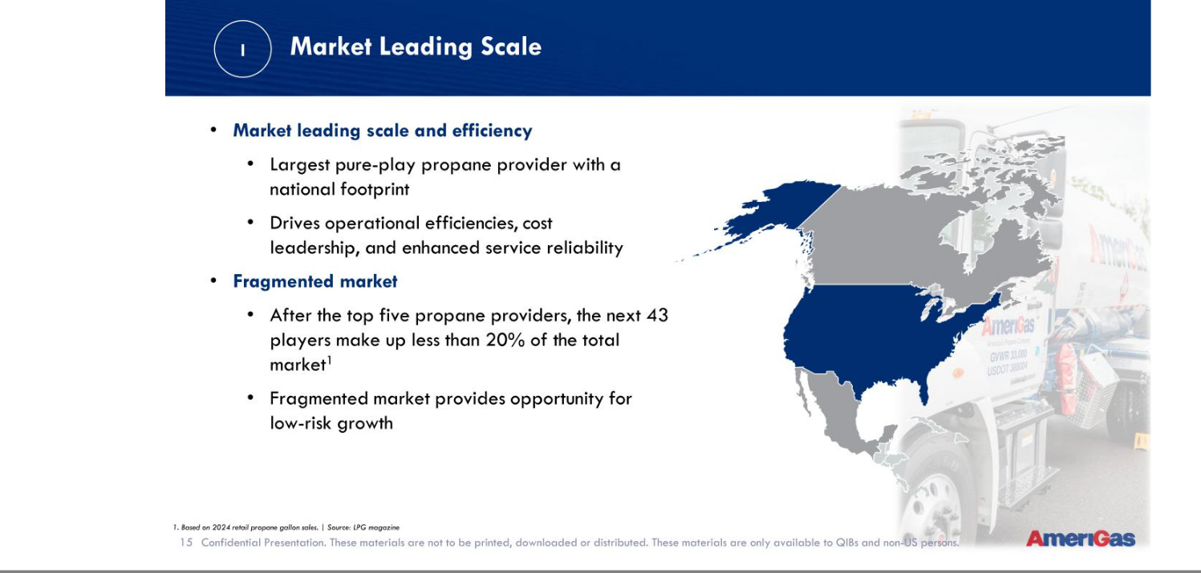

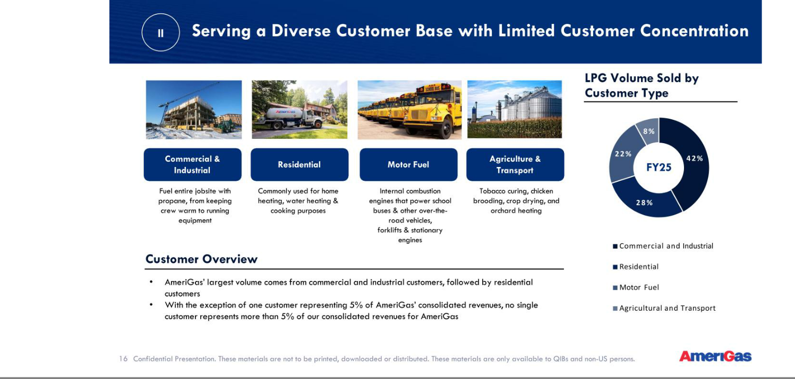

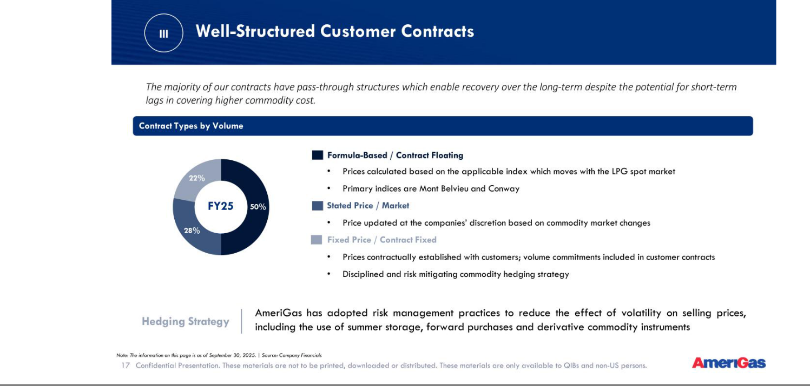

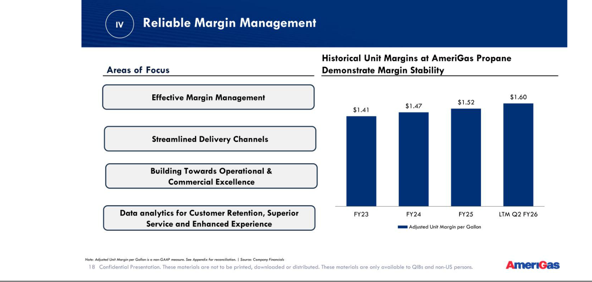

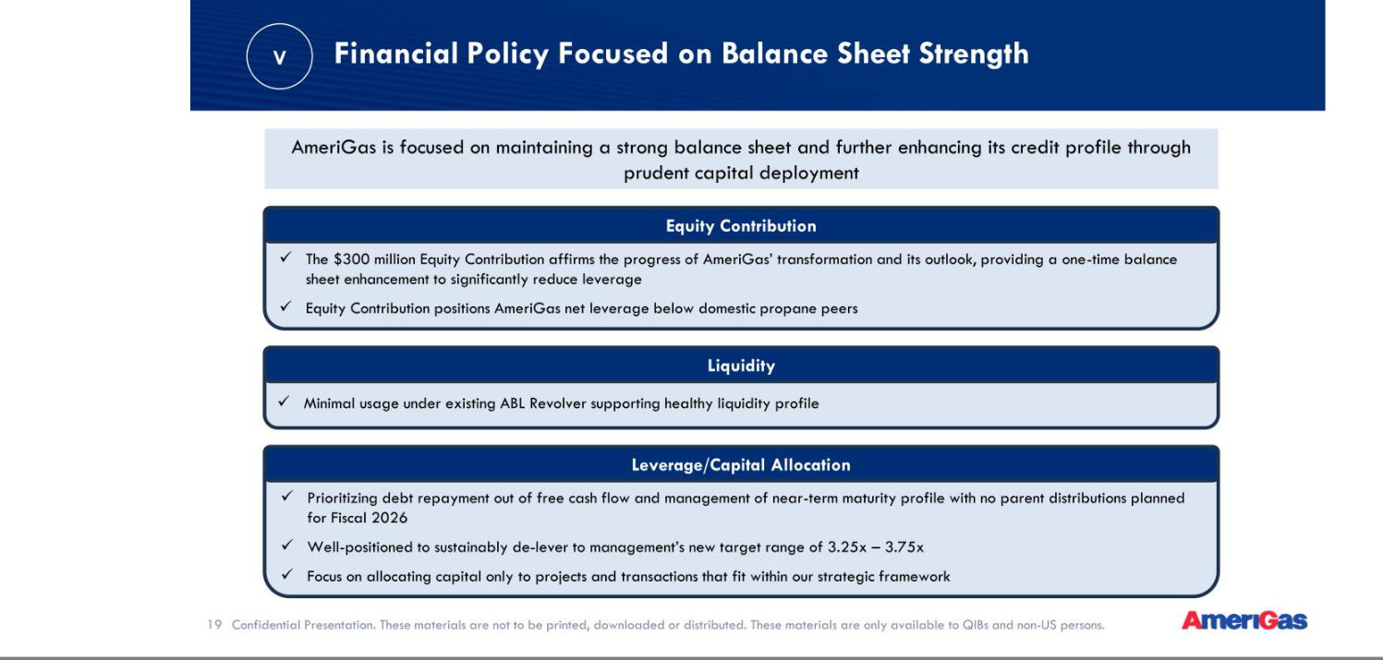

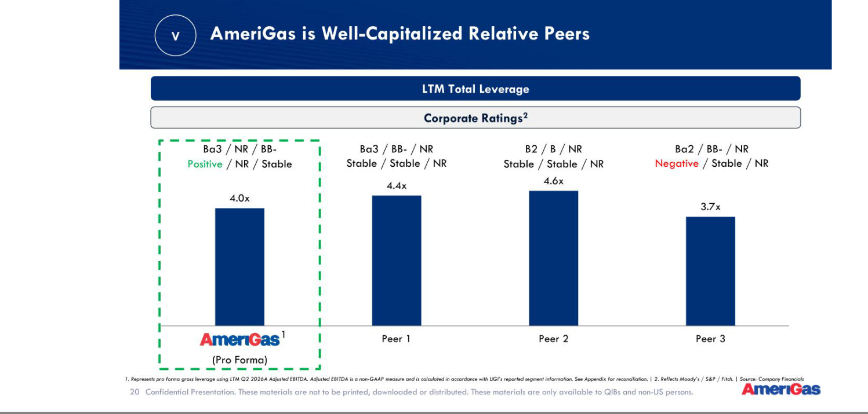

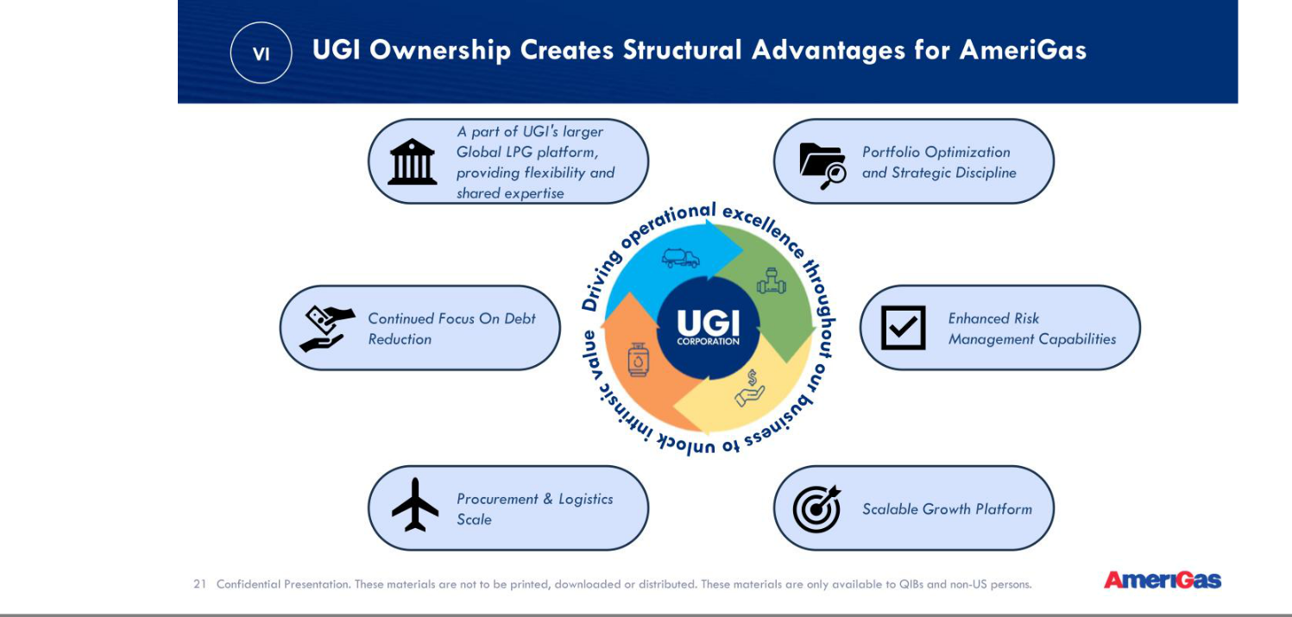

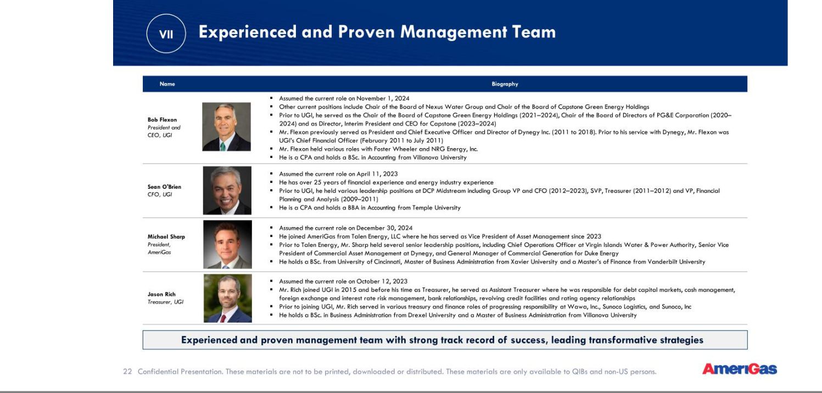

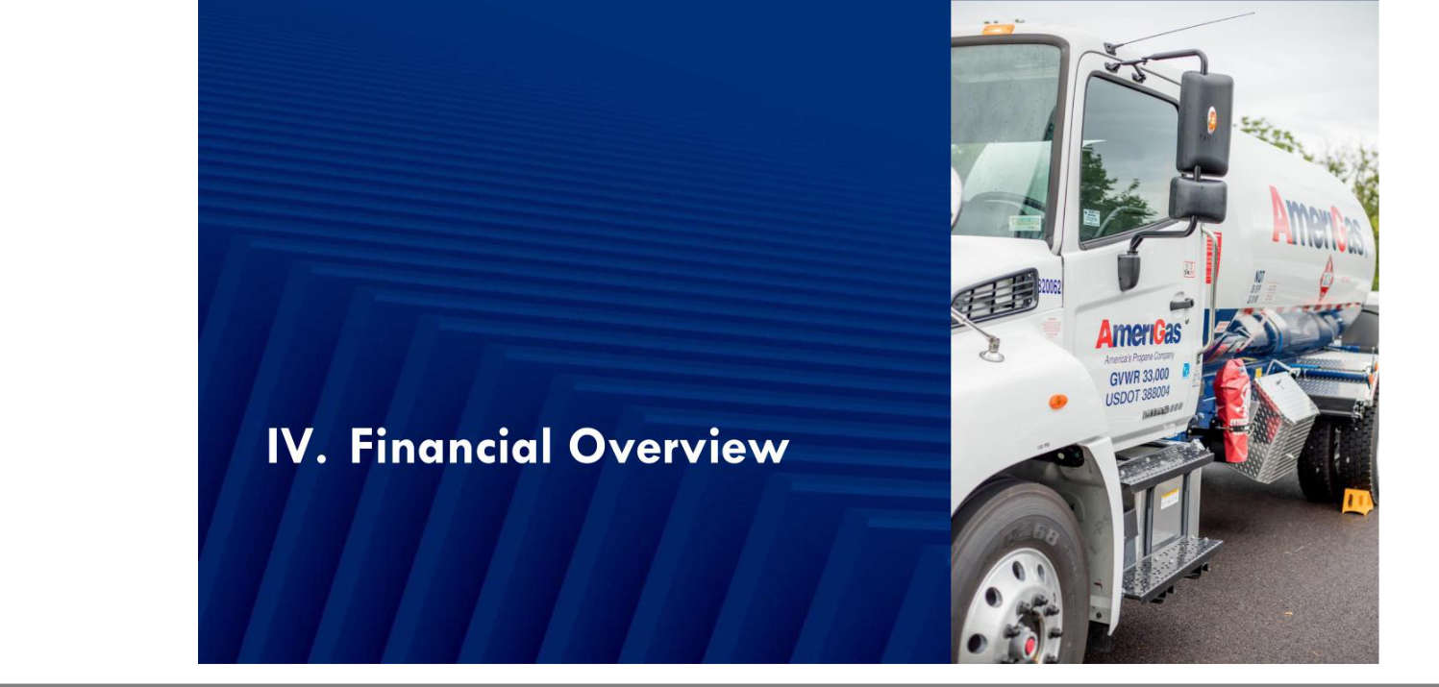

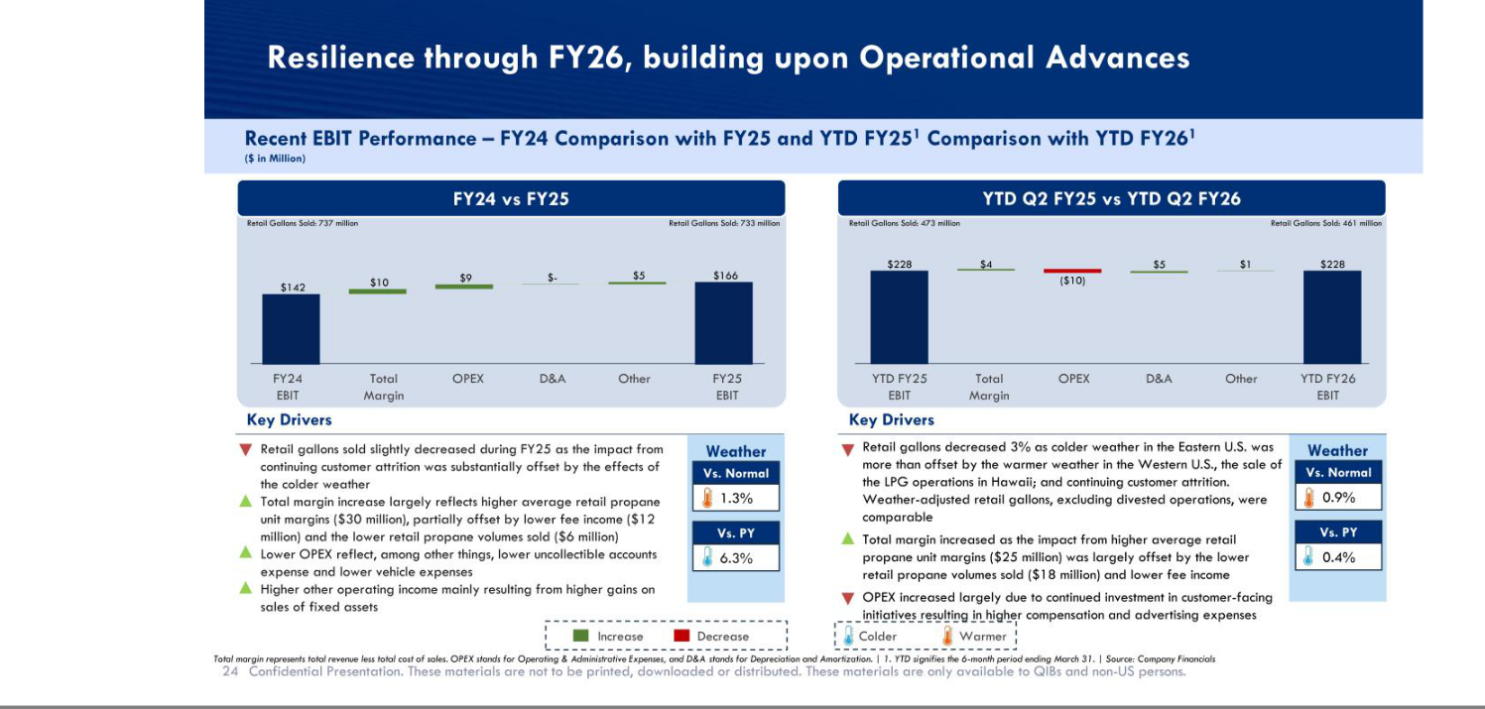

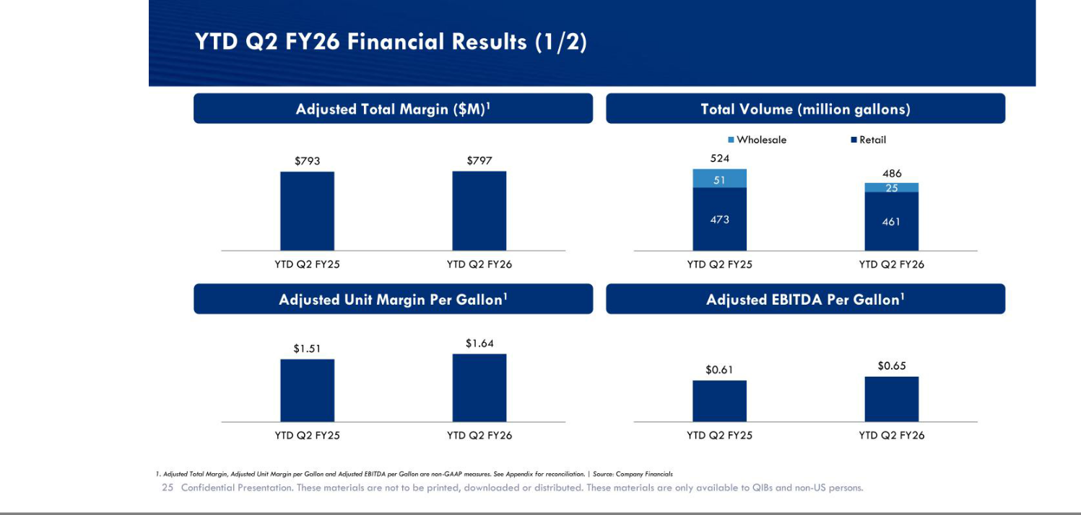

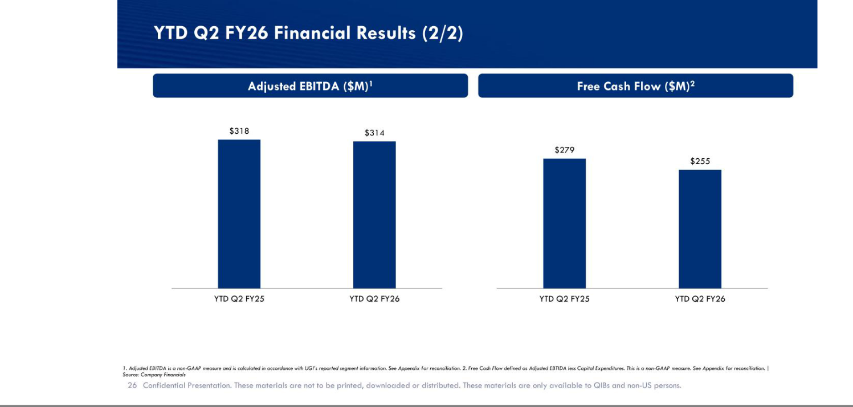

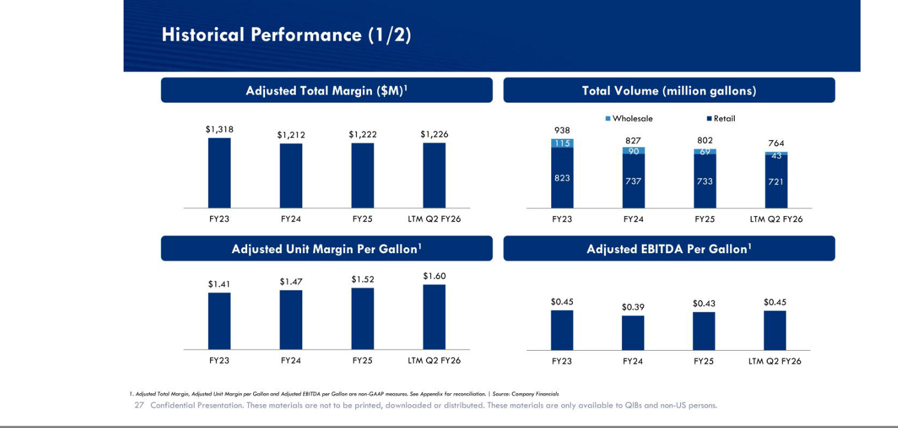

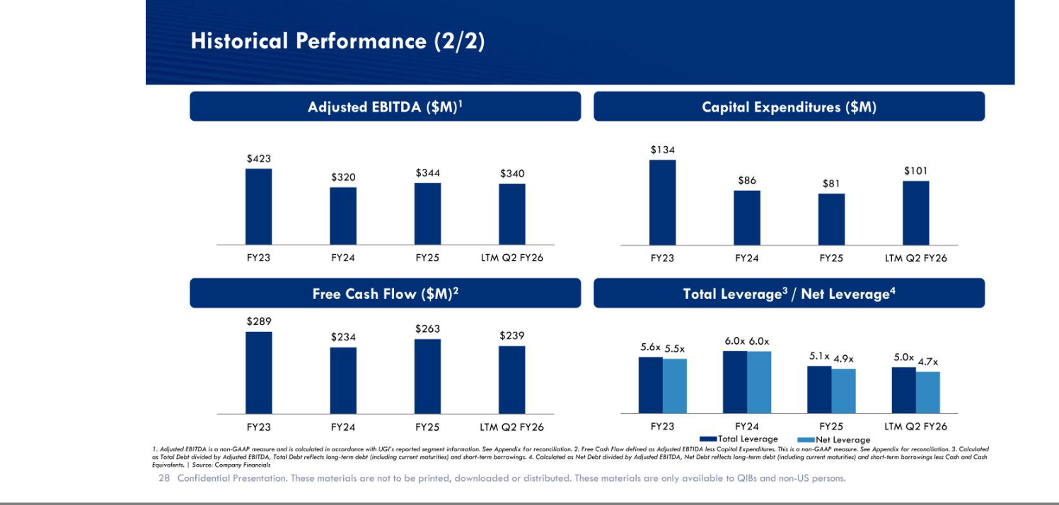

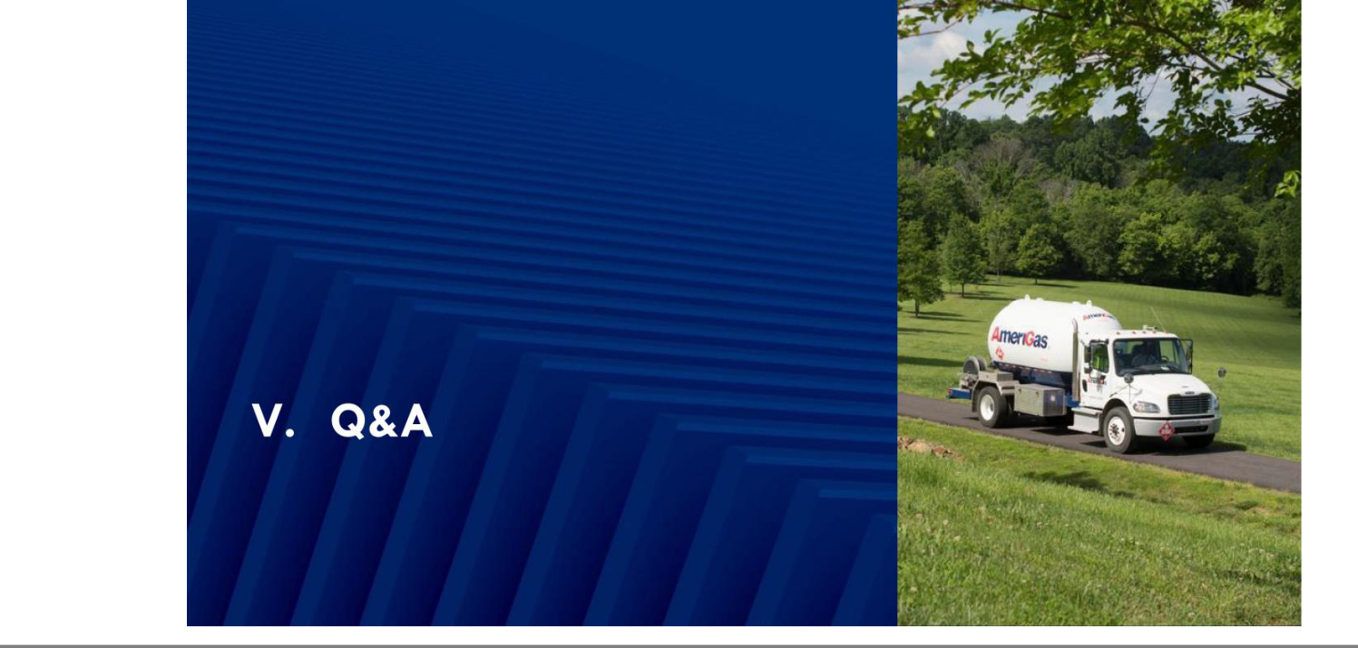

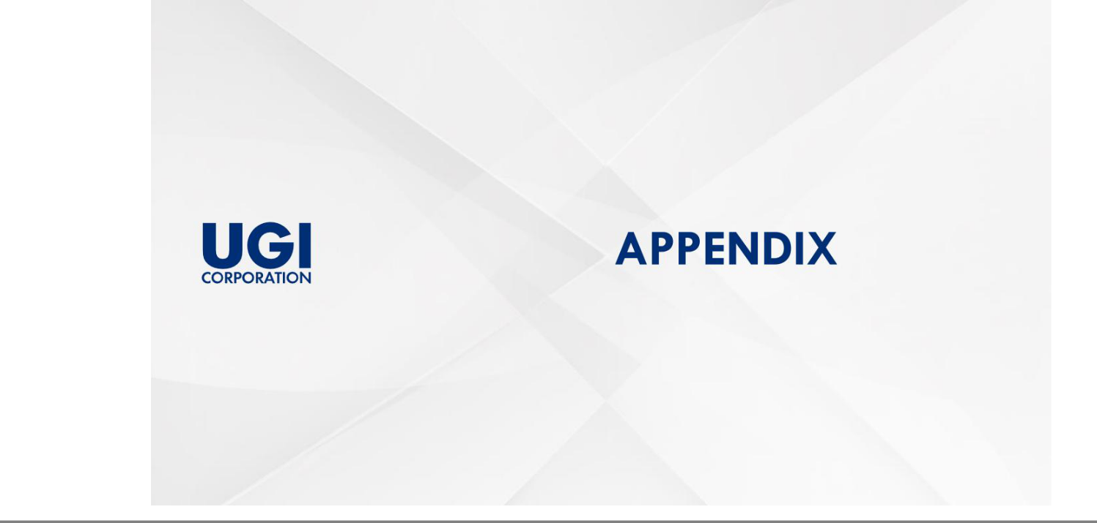

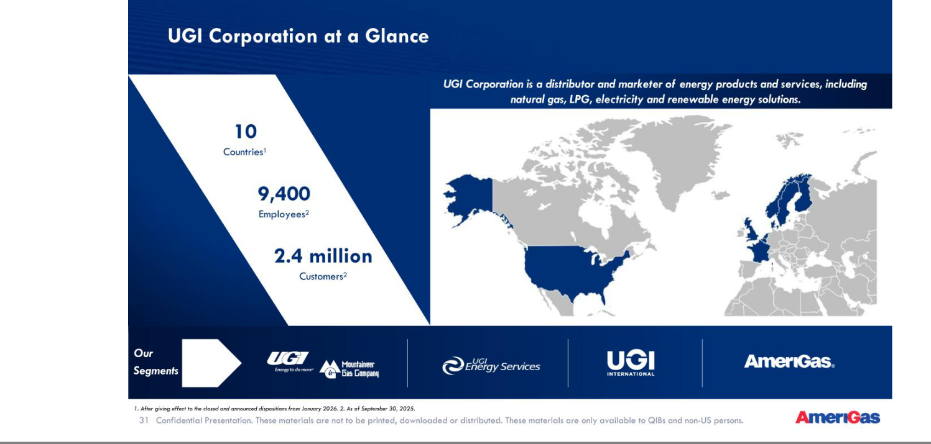

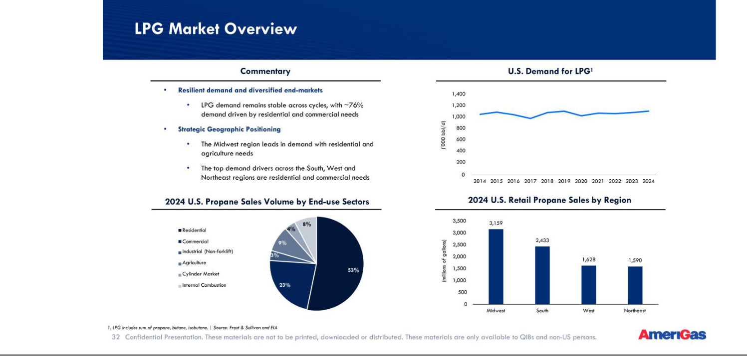

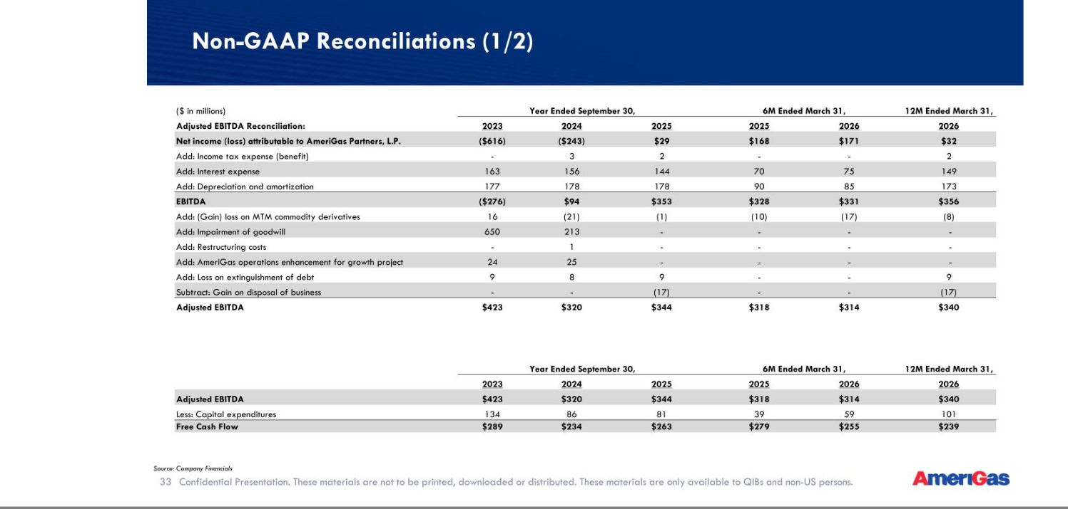

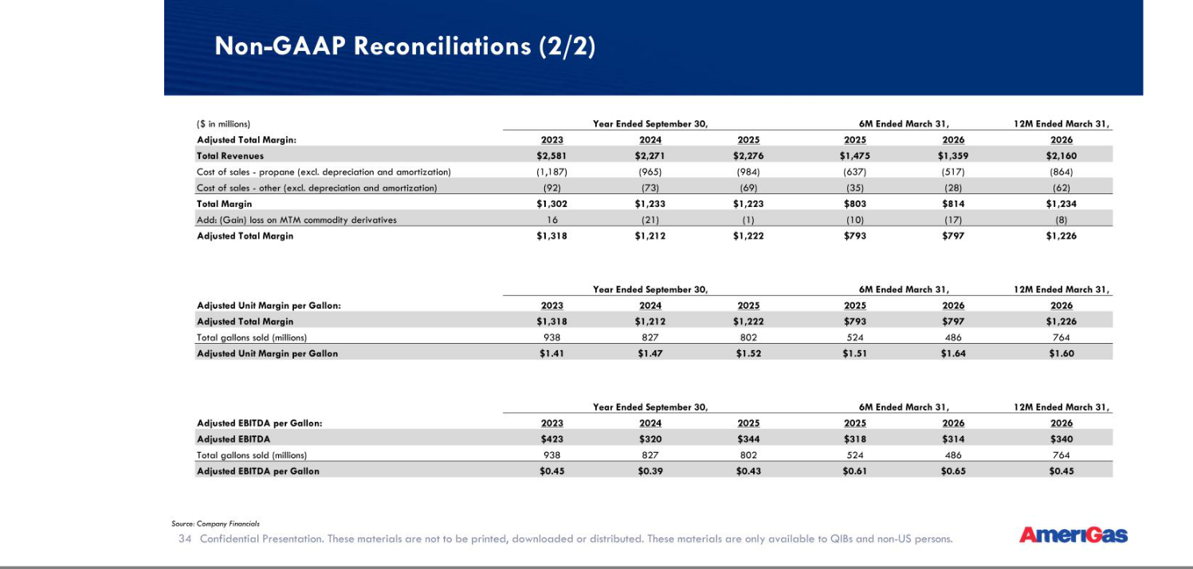

EXHIBIT 99.2
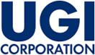

AmeriGas Partners, L.P. and AmeriGas Finance Corp. Commence Senior Notes Offering

VALLEY FORGE, Pa.—(BUSINESS WIRE)— May 11, 2026 —UGI Corporation (NYSE: UGI) announced today that its subsidiaries, AmeriGas Partners, L.P. (“AmeriGas Partners”) and AmeriGas Finance Corp. (together with AmeriGas Partners, the “Issuers”), intend to offer, subject to market and other conditions, $500,000,000 in aggregate principal amount of senior notes due 2031 (the “Notes”) in an offering to persons reasonably believed to be qualified institutional buyers pursuant to Rule 144A under the Securities Act of 1933, as amended (the “Securities Act”), and outside the United States in compliance with Regulation S under the Securities Act.

The Issuers intend to use the net proceeds from the offering, together with $300,000,000 in cash previously received by AmeriGas Partners in connection with an equity contribution by its parent, originally funded by UGI International, LLC, a wholly owned indirect subsidiary of UGI Corporation, and cash on hand, to (i) repurchase any and all of the Issuers’ 5.750% Senior Notes due 2027 (“2027 Notes”) and redeem any such 2027 Notes remaining thereafter, (ii) repurchase up to $175,000,000 aggregate principal amount of the Issuers’ 9.375% Senior Notes due 2028, (iii) repay $150,000,000 in outstanding indebtedness under the intercompany loan between AmeriGas Partners and UGI International, LLC and (iv) pay related fees and expenses.

The Notes will not be registered under the Securities Act, or any state securities laws, and may not be offered or sold in the United States absent registration, except pursuant to an exemption from the registration requirements of the Securities Act and applicable state securities laws.

This announcement is for informational purposes only and does not constitute an offer to sell, or the solicitation of an offer to buy, any note in any jurisdiction in which such an offer or solicitation, or the sale of these notes, would be unlawful without registration or qualification under the securities laws of such jurisdiction.

Cautionary Statements:

This press release contains “forward-looking statements” within the meaning of Section 21E of the Securities Exchange Act of 1934, as amended, Section 27A of the Securities Act of 1933, as amended, and the U.S. Private Securities Litigation Reform Act of 1995, including statements regarding the Issuers’ expectations regarding the aggregate principal amount of the Notes to be sold and the intended use of proceeds from the offering of the Notes. Readers are cautioned not to place undue reliance on these forward-looking statements and any such forward-looking statements are qualified in their entirety by reference to the following cautionary statements. All forward-looking statements speak only as of the date of this press release and are based on current expectations and involve a number of assumptions, risks, and uncertainties that could cause the actual results to differ materially from such forward-looking statements. Readers are strongly encouraged to read the full cautionary statements contained in AmeriGas Partners’ most recent annual report and in UGI’s filings with the U.S. Securities and Exchange Commission, and in UGI’s and the Issuers’ other communications with investors. UGI and the Issuers disclaim any obligation to update or revise any forward-looking statements.

About AmeriGas Partners

AmeriGas Partners is the largest retail propane marketer in the United States, with approximately 800 million gallons of propane sold annually to over 1.0 million customers from approximately 1,390 locations as of September 30, 2025.

About UGI

UGI Corporation (NYSE: UGI) is a distributor and marketer of energy products and services in the US and Europe. UGI offers safe, reliable, affordable, and sustainable energy solutions to customers through its subsidiaries, which provide natural gas transmission and distribution, electric generation and distribution, midstream services, propane distribution, renewable natural gas generation, distribution and marketing, and energy marketing services.

INVESTOR RELATIONS

610-337-1000
Tameka Morris, ext. 6297

Arnab Mukherjee, ext. 7498

EXHIBIT 99.3

AmeriGas Partners, L.P. and AmeriGas Finance Corp. Commence Cash Tender Offers for their 5.750% Senior Notes due 2027 and 9.375% Senior Notes due 2028

VALLEY FORGE, Pa., — (BUSINESS WIRE) — May 11, 2026 — UGI Corporation (NYSE: UGI) announced today that its subsidiaries, AmeriGas Partners, L.P. (“AmeriGas Partners”) and AmeriGas Finance Corp., (together with AmeriGas Partners, the “Offerors”) have commenced offers to purchase for cash (i) any and all of the Offerors’ outstanding 5.750% Senior Notes due 2027 (the “2027 Notes”) upon the terms and subject to the conditions set forth in the Offer to Purchase related to the 2027 Notes, dated May 11, 2026, and the related Letter of Transmittal and Notice of Guaranteed Delivery (the “2027 Notes Tender Offer”), and (ii) up to $175,000,000 (the “Tender Cap”) of the Offerors’ outstanding 9.375% Senior Notes due 2028 (the “2028 Notes” and, together with the 2027 Notes, the “Notes”) upon the terms and subject to the conditions set forth in the Offer to Purchase related to the 2028 Notes, dated May 11, 2026 (the “2028 Notes Tender Offer” and together with the 2027 Notes Tender Offer, the “Tender Offers”).

2027 Notes validly tendered and not validly withdrawn at or prior to 5:00 p.m., New York City time, on May 15, 2026 (the “2027 Notes Tender Offer Expiration Date”) will be eligible to receive a purchase price of $1,011.18 per $1,000 principal amount of 2027 Notes tendered.

2028 Notes validly tendered and not validly withdrawn at or prior to 5:00 p.m., New York City time, on May 22, 2026 (the “2028 Notes Tender Offer Early Tender Deadline”) will be eligible to receive a purchase price of $1,023.44 per $1,000 principal amount of the 2028 Notes tendered. 2028 Notes validly tendered and not validly withdrawn after the 2028 Notes Tender Offer Early Tender Deadline but at or prior to 5:00 p.m., New York City time, on June 9, 2026 (the “2028 Notes Tender Offer Expiration Date” and together with the 2027 Notes Tender Offer Expiration Date, the “Expiration Dates”) will be eligible to receive a purchase price of $993.44 per $1,000 principal amount of the 2028 Notes tendered.

Tendering holders will also receive accrued and unpaid interest from the last applicable interest payment date to, but not including, the applicable settlement date.

Subject to certain exceptions, tendered 2027 Notes can only be withdrawn before 5:00 p.m., New York City time, on the 2027 Notes Tender Offer Expiration Date, and tendered 2028 Notes can only be withdrawn before 5:00 p.m., New York City time, on the 2028 Notes Tender Offer Early Tender Deadline (together, the “Withdrawal Deadlines”). Following the respective Withdrawal Deadline, holders who have tendered their 2027 Notes or 2028 Notes, as applicable, may not withdraw such Notes unless the Offerors are required to extend withdrawal rights under applicable law.

Substantially concurrently with the commencement of the 2027 Notes Tender Offer, the Offerors will issue a conditional notice of full redemption to redeem any 2027 Notes not purchased in the 2027 Notes Tender Offer and that remain outstanding pursuant to the indenture governing the 2027 Notes. Nothing in this announcement should be construed as a notice of redemption with respect to the 2027 Notes, as any redemption will be made pursuant to a notice of redemption in accordance with the indenture governing the 2027 Notes.

The Offerors expressly reserve the right, in their reasonable discretion, subject to applicable law, to terminate either or both of the Tender Offers at any time prior to the applicable Expiration Date. The Offerors will not be required to purchase any of the corresponding Notes tendered unless certain conditions have been satisfied, including, but not limited to, the Offerors’ successful completion of one or more financing transactions, in an amount sufficient, together with cash received by AmeriGas Partners in connection with an equity contribution by UGI Corporation, originally funded by UGI International, LLC, a wholly owned indirect subsidiary of UGI Corporation, and cash on hand, to (i) fund the purchase of validly tendered 2027 Notes accepted for purchase in the 2027 Notes Tender Offer, and the redemption of any such 2027 Notes remaining thereafter, (ii) fund the purchase up to the Tender Cap of 2028 Notes accepted for purchase in the 2028 Notes Tender Offer, (iii) repay $150 million in outstanding indebtedness under the intercompany loan between AmeriGas Partners and UGI International, LLC and (iv) pay all related fees and expenses associated with the foregoing.

In connection with the Tender Offers, the Offerors have retained BNP Paribas Securities Corp. as the Dealer Manager. Questions regarding the Tender Offers should be directed to BNP Paribas Securities Corp. at dl.us.liability.management@us.bnpparibas.com, Attn: Liability Management Group, or by calling toll-free at (888) 210-4358 or international at (212) 841-3059. Requests for copies of each Offer to Purchase and related documents should be directed to D.F. King & Co., Inc., the Information Agent for the Tender Offers, at (800) 821-2712 (toll-free) or (212) 651-9295. The 2027 Notes Tender Offer documents are also available at www.dfking.com/ugi.

This announcement is not an offer to purchase or a solicitation of an offer to sell with respect to any 2027 Notes or 2028 Notes. Any offer to purchase the 2027 Notes or 2028 Notes will be made by means of an Offer to Purchase relating to such Notes and, with respect to the 2027 Notes Tender Offer, a related Letter of Transmittal and Notice of Guaranteed Delivery. No offer to purchase will be made in any jurisdiction in which such an offer to purchase would be unlawful.

Cautionary Statements:

This press release contains “forward-looking statements” within the meaning of Section 21E of the Securities Exchange Act of 1934, as amended, Section 27A of the Securities Act of 1933, as amended, and the U.S. Private Securities Litigation Reform Act of 1995, including statements regarding the Offerors’ intention to purchase any 2027 Notes or 2028 Notes, or plans to engage in any financing transactions. Readers are cautioned not to place undue reliance on these forward-looking statements and any such forward-looking statements are qualified in their entirety by reference to the following cautionary statements. All forward-looking statements speak only as of the date of this press release and are based on current expectations and involve a number of assumptions, risks, and uncertainties that could cause the actual results to differ materially from such forward-looking statements. Readers are strongly encouraged to read the full cautionary statements contained in AmeriGas Partners’ most recent annual report and in UGI’s filings with the U.S. Securities and Exchange Commission, and in UGI’s and the Offerors’ other communications with investors. UGI and the Offerors disclaim any obligation to update or revise any forward-looking statements.

About AmeriGas Partners

AmeriGas Partners is the largest retail propane marketer in the United States, with approximately 800 million gallons of propane sold annually to over 1.0 million customers from approximately 1,390 locations as of September 30, 2025.

About UGI

UGI Corporation (NYSE: UGI) is a distributor and marketer of energy products and services in the US and Europe. UGI offers safe, reliable, affordable, and sustainable energy solutions to customers through its subsidiaries, which provide natural gas transmission and distribution, electric generation and distribution, midstream services, propane distribution, renewable natural gas generation, distribution and marketing, and energy marketing services.

INVESTOR RELATIONS

610-337-1000

Tameka Morris, ext. 6297

Arnab Mukherjee, ext. 7498

Source: UGI Corporation

